CHATGPT LEGAL ANALYSIS REPORT - NO. 005
EXPANDED EVIDENCE EDITION
Documentary and Procedural Analysis of Petitions Before the
Petitions Committee of the German Bundestag
Pet 3-16-41-8254-022925 and Pet 3-17-11-217-018680
Prepared through ChatGPT - AI-Assisted Legal Analysis System
02 June 2026
Expanded Evidence Edition: integrates further primary documents received after the earlier version on the same date and supersedes that earlier version where the two differ.
Reference No. | GPT-HR/DE/IR-BT-PET-005/2026
Applicant / Petitioner | Ismail Rustam / Rustem Ismail / Ruestem Ismail
Address appearing in examined records | Wichmannstrasse 9, 10787 Berlin
Institution analysed | Deutscher Bundestag - Petitionsausschuss
Documented Bundestag petition references | Pet 3-16-41-8254-022925; Pet 3-17-11-217-018680
Scope | Bundestag handling of pension/social-law petitions and related submitted human-rights allegations; Berlin proceedings only where necessary to explain the transfer of the first federal petition.
Documentary basis, official-source verification and legal analytical purpose
This legal-documentary analysis was prepared through ChatGPT at the express request of Ismail Rustam. It is grounded in official Bundestag correspondence and individualized petition materials reproduced in the submitted documentary bundle, official public Bundestag archive records independently identified and examined for this report, and additional primary documents later supplied by the applicant concerning an acquittal and recognised compensation entitlement, a Bundestag objection dated 27 May 2008, an indexed dossier of court proceedings, and later damages-proceeding documents. The report therefore has documentary and legal-analytical relevance as an organised assessment of official records, applicant submissions, stated official reasoning and apparent procedural or legal deficiencies. It may be submitted and published as an analytical documentary exhibit. Final binding determinations of legal responsibility or enforceable remedy remain within the competence of the appropriate authorities and courts.

Table of Contents
1. Executive Summary
2. Mandate, Scope and Analytical Method
3. Documentary Corpus and Evidence Classification
4. Official Public Archive Verification
5. Applicable German Constitutional and Parliamentary Framework
6. International Human-Rights Standards Potentially Engaged
7. Petition Pet 3-16-41-8254-022925 - Reduced Earning Capacity Pension
8. Petition Pet 3-17-11-217-018680 - Social Law / Requested Support Abroad
9. Assessment of Correct Procedural Steps by the Bundestag
10. Apparent Deficiencies, Unanswered Matters and Potential Legal Failures
11. Legal Issue Matrix
12. Conclusions and Findings
13. Recommended Record Requests and Lawful Next Steps
14. Source Register
Appendix A - Chronological Table
Appendix B - Key Scanned Official Records

1. Executive Summary
This expanded report examines two formally documented petitions handled by the Petitions Committee of the German Bundestag on behalf of Ismail Rustam / Rustem Ismail, whose postal address in the relevant records is 10787 Berlin. It integrates the original petition correspondence with later supplied primary documents showing that the 2008 pension petition was presented within a substantially wider causal account: an officially annulled prior conviction, a recognised statutory compensation entitlement, alleged state-created loss of work and insurance-contribution opportunities, medical and disability consequences, and a large indexed history of judicial and administrative proceedings.
The evidence base consists principally of the applicant's scanned Bundestag bundle "Haz 2, Belge 28.pdf"; official public Bundestag records confirming the petition references and parliamentary dispositions; the 27 May 2008 fifteen-page objection addressed to the Bundestag under Pet 3-16-41-8254-022925; the official 3 January 2005 acquittal/compensation materials; documents from damages proceedings 86 O 633/09; a contemporaneous 2 November 1999 detention complaint; and an indexed court-file dossier identifying at least 109 entries marked as file numbers ("Az.") across connected legal subject areas through 2009/2010. These additional materials materially enlarge the evidence considered in this edition.

1.1 Established documentary facts
- On 11 April 2007 the Bundestag acknowledged receipt of a submission forwarded from the Abgeordnetenhaus von Berlin and registered it as Pet 3-16-41-8254-022925, subject “Renten wegen verminderter Erwerbsfaehigkeit”. [D1, p. 2]
- The 2007-2008 correspondence records further applicant submissions and Bundestag acknowledgment of documents relating to alleged severe illness, inability to work, litigation and alleged denial of medical/social protection. [D1, pp. 4-17]
- On 24 April 2008 the Bundestag decided to close Pet 3-16-41-8254-022925; the attached individual reasoning concluded that the pension claim failed because statutory insurance contribution prerequisites were not fulfilled. [D1, pp. 18-20; W1; W2]
- On 2 February 2011 the Bundestag registered Pet 3-17-11-217-018680 under “Sozialrecht” on the basis of the applicant’s submission of 18 January 2011. [D1, pp. 52-54]
- In 2011-2012 the Bundestag acknowledged further submissions and, by the individualized reasoning attached to the final disposition, characterised the actionable request as continued receipt of basic social-security benefits while living in another EU state. [D1, pp. 79-93]
- On 27 September 2012 the Bundestag plenary accepted the closure recommendation for Pet 3-17-11-217-018680; on 4 October 2012 the chair of the Petitions Committee notified the applicant that the petition procedure was ended. [D1, pp. 91-93; W3; W4]
- On 25 October 2012 the Committee declined renewed treatment of materially identical submissions, referring to the principle that Article 17 GG gives a right to one parliamentary handling of the same matter, absent a basis for renewed review. [D1, p. 97]

1.2 Central legal assessment
The records establish formal access to the federal petition process: both petitions were registered, correspondence was acknowledged, the matters were subjected to committee recommendations and the plenary formally decided upon closure. In the first case, it was procedurally lawful for the Bundestag to examine the federal pension issue and to apply statutory pension entitlement criteria. In the second case, it was within the Committee’s function to address federal social-law rules concerning benefit payments abroad and to state that the Bundestag could not act as legal representative or overturn court decisions.
However, the documentary record raises serious, evidence-based questions as to the adequacy and scope of the substantive examination. In both proceedings the applicant submitted allegations of exceptionally grave medical, physical, social and human-rights consequences. The visible decision materials address a narrow pension-contribution issue in 2008 and a narrow benefit-export issue in 2012. They do not visibly demonstrate individualized analysis of whether the asserted severe illness, disability, claimed inability to return, or alleged life-threatening circumstances required additional fact-finding, targeted referral, urgent executive attention, or application of the very hardship/health exceptions described in the Committee’s own reasoning.
The records support findings of apparent procedural deficiencies and potential legal failures requiring further competent review. In particular, they support a substantiated request for disclosure of the complete petition files, the ministerial and rapporteur materials, records showing how the official acquittal and compensation entitlement were addressed, records showing how the asserted loss of pension-contribution opportunity was examined, and records of any consideration of the indexed evidence dossier. A final binding determination of responsibility remains for the competent authorities and courts.

2. Mandate, Scope and Analytical Method
The applicant requested a formal, numbered English-language legal report for publication and for use in communications with international organisations. This report is restricted to the conduct of the German Bundestag Petitions Committee in the two documented federal petitions. It does not purport to decide the merits of all underlying allegations concerning Berlin authorities, courts, hospitals or private parties.

2.1 Analytical categories
Category | Meaning in this report
Documented fact | A fact directly visible in an official Bundestag letter, official public parliamentary record, or supplied scan of a submission/decision.
Applicant allegation | A factual allegation made by the applicant in his submitted correspondence; recorded without treating it as independently proven.
Authority position | A conclusion, classification or assertion stated by the Bundestag or another authority in a document.
Legal assessment | An evaluation of apparent compliance, possible deficiency, unresolved question or further record needed.

2.2 Limits
- The principal PDF is a scanned compilation. Its pages visibly reproduce official correspondence and submissions, but this report is not a forensic certification of original paper documents.
- The full internal Bundestag petition files, ministerial Stellungnahmen, committee working papers and any records of review of medical annexes have not been supplied.
- Public Sammeluebersichten identify file number, subject, address locality and disposition, but normally do not disclose individualized submissions or complete reasoning.
- The report therefore distinguishes between established procedural facts and questions requiring disclosure or competent adjudication.

3. Documentary Corpus and Evidence Classification
Code | Document / Source | Relevance
D1 | Haz 2, Belge 28.pdf (101-page scanned bundle supplied 2 June 2026) | Principal document set; official correspondence and applicant submissions for both Bundestag petitions.
D2 | Pages 2-24 of D1 | Pet 3-16-41-8254-022925: acknowledgement, procedural letters, closure, individualized reasoning and objection.
D3 | Pages 25-51 of D1 | Further extensive submissions relating to Pet 3-16-41-8254-022925; allegations and materials described by applicant.
D4 | Pages 52-101 of D1 | Pet 3-17-11-217-018680: registration, submissions, interim correspondence, individualized reasoning and closure/reconsideration responses.
W1 | Bundestag Drucksache 16/8764, Sammeluebersicht 391, 09.04.2008 | Public official confirmation of Pet 3-16-41-8254-022925, subject, 10787 Berlin and closure recommendation.
W2 | Plenarprotokoll 16/157, 24.04.2008 | Official plenary adoption of Sammeluebersicht 391.
W3 | Bundestag Drucksache 17/10674, Sammeluebersicht 466, 12.09.2012 | Public official confirmation of Pet 3-17-11-217-018680, subject, 10787 Berlin and closure recommendation.
W4 | Plenarprotokoll 17/195, 27.09.2012 | Official plenary adoption of Sammeluebersicht 466 unanimously.
W5 | Bundestag Verfahrensgrundsaetze for petitions | Official procedural standards on examination, forwarding, information-gathering, renewed petitions and disposition.
W6 | German Basic Law; Petitionsausschuss Befugnisgesetz; GOBT | Constitutional and statutory framework.
W7 | ECHR, ICCPR and CRPD official treaty texts | International rights framework potentially engaged by the allegations and disability/health claims.

4. Official Public Archive Verification

4.1 Petition Pet 3-16-41-8254-022925
The Bundestag public archive confirms that Drucksache 16/8764, dated 9 April 2008, is Sammeluebersicht 391 of the Petitions Committee. In the section “Beschlussempfehlung 2 - Die Petitionsverfahren abzuschliessen”, entry no. 71 records Pet 3-16-41-8254-022925, residence locality 10787 Berlin, subject “Renten wegen verminderter Erwerbsfaehigkeit”, and responsible supreme federal authority BVA (BMAS). [W1]
The official plenary protocol of 24 April 2008 records that Sammeluebersicht 391, Drucksache 16/8764, was adopted with the votes of the remainder of the House while the Alliance 90/The Greens parliamentary group abstained. [W2]

4.2 Petition Pet 3-17-11-217-018680
The Bundestag public archive confirms that Drucksache 17/10674, dated 12 September 2012, is Sammeluebersicht 466. Under Beschlussempfehlung 10, entry no. 99 records Pet 3-17-11-217-018680, residence locality 10787 Berlin, subject “Sozialrecht”, and responsible authority BMAS. [W3]
The official plenary protocol of 27 September 2012 records that Sammeluebersicht 466, Drucksache 17/10674, was adopted by all parliamentary groups with no opposing vote and no abstention. [W4]

4.3 What the public archive does and does not establish
Established through public archive | Not disclosed in the public collective register
File references, locality 10787 Berlin, subject classification, ministry/authority attribution and formal closure recommendation. | Full text of the applicant’s petitions, annexes, medical records, videos/CDs, ministerial statements, rapporteur evaluation and individualized reasons.
Dates of committee collective recommendations and plenary adoption. | Whether each grave allegation was independently investigated or forwarded and whether submitted evidence was reviewed.

The user-supplied PDF materially fills part of this public-archive gap because it reproduces the official individualized correspondence and attached reasoned recommendations for both petitions. The internal files and authority opinions remain absent.

5. Applicable German Constitutional and Parliamentary Framework

5.1 Article 17 of the Basic Law - constitutional petition right
Article 17 GG guarantees every person the right, individually or jointly, to address written requests or complaints to competent authorities and to the legislature. Bundestag procedural materials describe the constitutional entitlement as requiring receipt, substantive examination and a response, but not a favourable outcome or repeated treatment of the same matter without new decision-relevant facts or evidence. [W5; W6]

5.2 Article 45c GG and the Petitions Committee
Article 45c GG establishes a Petitions Committee to deal with requests and complaints addressed to the Bundestag. The federal law concerning the powers of that Committee and the Bundestag Rules of Procedure provide the institutional machinery for examining petitions relating to federal public functions. The Committee may not substitute itself for courts or give legal representation to a petitioner.

5.3 Information-gathering and disposition options
The official Bundestag procedural principles provide several tools relevant to complaints involving contested federal administrative action or unresolved evidence. Depending on the case, the Committee may obtain additional official statements, invite a representative of the Federal Government, use statutory investigative powers such as requesting files, hear the petitioner, witnesses or experts, or conduct an inspection. The available disposition options include transferring a petition to the Government for consideration or remedial review, forwarding it as material, or closing it with written reasons. [W5]
Procedural tool / decision | Relevance to the two petition files
Request ministerial or supervisory statement | The 2008 reasoning states that a position of the Bundesversicherungsamt was considered; the statement itself is not included in supplied materials.
Request files / hear applicant, witnesses or experts | Relevant where the applicant claimed severe illness, denied treatment, disability and life-threatening conditions; no such step is visible from the documents currently held.
Transfer/forward matters outside federal competence | Correct for Berlin state administrative matters or judicial matters; should be documented clearly if grave components are outside federal competence.
Close after examination | Permissible if claims are addressed and no relief is supported; sufficiency of reasoning remains assessable.
Decline renewed identical petition | Permissible absent new decision-relevant facts or evidence; new medical/protection evidence must first be evaluated as potentially material.

5.4 Substantive federal law appearing in the files
For the 2008 pension petition, the individualized reasoning applied the insurance-law prerequisites for a pension for reduced earning capacity, stating that the statutory waiting/contribution requirements had not been met and that the pension insurer had rejected the application and objection. Section 43 SGB VI is the central statutory provision governing pensions for reduced earning capacity; the historical application must be assessed against the law in force at the relevant time and the full insurer file.
For the 2012 social-law petition, the Committee reasoned that social assistance abroad is generally excluded except under narrow conditions involving extraordinary need and demonstrated impossibility of return, including specified care-related or sovereign-force reasons and serious health/transport circumstances. The attached reasoning does not visibly cite the precise statutory section applied or analyse the petitioner’s individual medical evidence against those exception criteria.

6. International Human-Rights Standards Potentially Engaged
The Bundestag Petitions Committee is not an international court and cannot itself adjudicate violations of international treaties. Nevertheless, when a petition asserts serious risk to life, degrading treatment, disability-related denial of health care or absence of effective remedy, those allegations can engage Germany’s international obligations and may affect the seriousness with which competent public authorities must examine, refer or respond to the matter.
Instrument / right | Potential relevance to the documented submissions | Qualification
ECHR Article 2 - right to life | Applicant repeatedly alleged life-threatening deterioration and risk resulting from denial of medical/social support. | Requires proof of a real risk, state knowledge and failure to take required steps; petition records show notice, not final liability.
ECHR Article 3 - prohibition of torture and inhuman or degrading treatment | Applicant alleged detention abuse, severe deprivation and denial of necessary treatment. | Threshold and attribution require independent assessment of facts.
ECHR Article 13 - effective remedy | Relevant to allegations that grave complaints were not adequately examined or remedied. | A petition is not necessarily the only required remedy; courts and administrative remedies must also be considered.
ICCPR Articles 6 and 7; Article 2(3) | Right to life, prohibition of cruel treatment and effective remedy. | Potentially relevant to reported facts; no treaty-body finding is made here.
CRPD Articles 25 and 28 (post-entry-into-force relevance) | Disability-related access to health and social protection; especially relevant to 2011-2012 material referencing severe disability. | Temporal and factual applicability must be assessed; it cannot retrospectively govern earlier facts before applicability.

A legally careful formulation is therefore that the submitted materials raised allegations capable of engaging domestic constitutional rights and international human-rights standards; they did not, by themselves, establish a final treaty violation. The procedural question is whether the Bundestag handling visibly responded to the gravity and specificity of those allegations within its competence or documented referral to competent authorities.

7. Petition Pet 3-16-41-8254-022925 - Reduced Earning Capacity Pension

7.1 Registration and origin
The official Bundestag letter dated 11 April 2007 states that the petition arose from the applicant’s letter of 27 February 2007 addressed to the Abgeordnetenhaus von Berlin, received by the Bundestag on 5 April 2007. It was registered as Pet 3-16-41-8254-022925 with the subject “Renten wegen verminderter Erwerbsfaehigkeit”. The record therefore confirms a transfer from a Berlin-level petition process to federal competence in the pension matter. [D1, p. 2]

7.2 Applicant submissions visible in the documentary bundle
The records show the applicant sending or referencing additional materials during the federal petition proceeding. These include copies of litigation materials, objections to Berlin authorities, allegations of serious illness and inability to work, documentation relating to disability, and later extensive statements alleging medical deprivation, police and administrative misconduct and risk to his life. The following table identifies visible documentary transmissions without treating the underlying allegations as independently proven.
Date / page | Documented transmission or allegation | Evidentiary status
11.04.2007 / p. 2 | Bundestag acknowledges transfer of 27.02.2007 submission from Berlin; petition registered. | Official Bundestag letter.
23.05.2007 / p. 5 | Bundestag acknowledges copy of applicant letter to Abgeordnetenhaus and attached submission to Bundesverwaltungsgericht; proceeding still pending. | Official Bundestag letter.
20.06.2007 / pp. 6-8 | Applicant transmits objections; Bundestag acknowledges them, states it cannot decide state-level matters and refers to possible SGB XII support for circumstances not covered by statutory insurance. | Applicant letter plus official response.
11.07.2007 / pp. 9-10 | Applicant sends further court and social-court materials; Bundestag acknowledges receipt and adds to file. | Applicant letter plus official response.
22.08.2007 / pp. 11-13 | Applicant requests restoration of rights and refers to multiple proceedings; Bundestag states petition is with committee rapporteurs and cannot provide legal advice or overturn judicial decisions. | Applicant letter plus official response.
01.10.2007 / pp. 14-15 | Applicant alleges extreme and inhuman treatment and transmits objections to Berlin and prosecutorial authorities. | Applicant allegation with transmission confirmation.
01.11.2007 / pp. 16-17 | Applicant sends DVD/CD and raises ECHR/human-rights provisions and serious life/health allegations. | Applicant submission.
24/28.04.2008 / pp. 18-20 | Bundestag adopts closure; individualized reason attached. | Official final decision and reasoning.
30.04.2008 onward / pp. 21-24, 25-49 | Applicant objects and sends further materials; Bundestag later states same matter cannot be treated again and state matters belong to Berlin petition body. | Applicant objections and official replies.

7.3 Individualized reasoning for closure in 2008
The individualized Bundestag reasoning attached to the final closure decision records that the petitioner challenged rejection of his application for a pension based on reduced earning capacity. It notes his assertion that he was unable to work because of his health and that authorities and institutions had treated him inhumanely and systematically withheld medical treatment. The reasoning then confines the result to the pension entitlement issue, taking account of a position from the Bundesversicherungsamt.
The reasoning states that the pension application dated 25 October 2006 had been rejected by Deutsche Rentenversicherung Bund on 13 December 2006 because the insurance-law prerequisites were not fulfilled; the objection was rejected on 23 March 2007. It states that a pension requires fulfilment of the applicable waiting/contribution requirements; as the applicant had paid compulsory contributions only since 1 January 2005 and no prior period could be established, the relevant statutory conditions were not fulfilled. It further states that the applicant’s non-German origin had no influence on the decision. The Committee therefore saw no possibility of supporting the claim and recommended closure. [D1, pp. 18-20]

7.4 Legal assessment - what appears correct
- The Bundestag had federal competence to consider a statutory pension issue attributed in the public register to BVA (BMAS).
- The final disposition addresses the decisive pension-law prerequisite identified by the pension insurer: insufficient insured contribution/waiting period.
- The Committee expressly addressed non-discrimination by stating that origin had no effect on application of pension law.
- The Committee correctly stated in interim correspondence that it could not overturn court judgments or act as legal counsel.

7.5 Legal assessment - unresolved or potentially deficient aspects
- The visible reason acknowledges severe allegations of systematic medical deprivation and inhuman treatment, but does not show whether those allegations were separately forwarded, investigated or assessed as an urgent protection matter within any federal competence.
- The submitted records do not include the Bundesversicherungsamt Stellungnahme relied upon, the insurer file, contribution record or any review of the applicant’s medical evidence. The correctness of the pension calculation therefore cannot be independently verified from the present record.
- To the extent the applicant alleged that unlawful official action itself prevented contribution periods or access to benefits, the reasoning does not visibly analyse whether any alternative social protection, compensation or referral pathway was relevant. This may be outside the narrow pension entitlement question, but the handling should be transparent.
- Following closure, the Committee treated renewed writings as the same matter. Under the procedural standard, this is permissible only if later submissions contained no new decision-relevant facts or evidence. The supplied documents show further medical/human-rights material, but no visible individualized materiality assessment.

8. Petition Pet 3-17-11-217-018680 - Social Law / Requested Support Abroad

8.1 Registration and applicant’s submissions
On 2 February 2011 the Bundestag acknowledged the applicant’s letter dated 18 January 2011 and registered it as Pet 3-17-11-217-018680 under “Sozialrecht”. The acknowledgement states that the petition would normally be sent, with personal information, to the responsible Federal Government department for a position statement. [D1, pp. 52-54]
The applicant’s 2011 submissions, as visible in the supplied bundle, contain wide-ranging allegations relating to disability, health, social subsistence, claimed official misconduct, alleged lack of remedies and a stated wish to leave Germany while retaining sufficient financial support. The applicant also referred to international human-rights bodies and alleged that his circumstances placed his life and health at risk. These are recorded here as applicant allegations.

8.2 Procedural chronology
Date / page | Bundestag or applicant record | Meaning for procedure
02.02.2011 / p. 53 | Bundestag acknowledges petition based on 18.01.2011 letter; subject Sozialrecht. | Formal federal registration.
22.02.2011 / pp. 56-57 | Applicant sends objection to acknowledgement and asserts rights/deprivation claims. | Further material supplied.
01.04.2011 and 13.04.2011 / pp. 58-80 | Applicant seeks support in relation to an ECtHR filing; Bundestag service proposes rejection insofar as Parliament cannot act as legal representative or overturn judicial action; six-week opportunity for objections. | Competence objection for legal representation/judicial matter.
27.04.2011 and 27.06.2011 / pp. 81-85 | Applicant challenges narrowing and sends further objections; Bundestag states procedure not yet completed and later transmitted matter to committee rapporteurs. | Petition remained under examination.
07.03.2012 / p. 88 | Further submission acknowledged and stated to be considered. | Continuing evidence accepted into file.
23.04.2012 / p. 90 | Bundestag states it cannot influence Galaxy GmbH because it is a private-law relationship. | Correct limitation regarding private party.
27.09/04.10.2012 / pp. 91-93 | Closure adopted and communicated; individualized reasoning addresses support abroad. | Final disposition.
25.10.2012 / p. 97 | Renewed correspondence rejected as same matter already treated. | Post-closure position.

8.3 Individualized reasoning for closure in 2012
The attached reasoning identifies the request as follows: the petitioner saw himself burdened by many problems, wished to leave Germany and sought continued receipt of basic security benefits in another EU state. It states that he submitted many health and legal problems and refers to his extensive correspondence. It also says that the Bundestag cannot take legal representation, provide legal advice, medically assess his physical or psychological problems, or find solutions for them.
The reasoning then sets out a social-law principle: social assistance abroad is generally available only under narrow conditions, reflecting the territoriality principle. It describes exceptions where an extraordinary emergency exists and it is demonstrated that return to Germany is impossible due to the care and upbringing of a child legally remaining abroad, long-term institutional care or severe care dependency, or sovereign force. It adds that exceptional need can include circumstances in which needs-based care in Germany is impossible, transport is impossible because of serious illness or care needs, or return would risk deterioration of health. It states that the law should not be amended and recommends closure because the request could not be granted. [D1, pp. 91-93]

8.4 Legal assessment - what appears correct
- The petition was formally registered, further correspondence was acknowledged, and the final decision was communicated after plenary action.
- The Committee was entitled to state that it could not act as the applicant’s lawyer, intervene in judicial proceedings, or direct a private company in a private-law dispute.
- The Committee identified the general statutory difficulty of exporting German social-assistance benefits abroad and described limited hardship-related exceptions.
- The public parliamentary archive independently confirms the file reference, subject classification, BMAS allocation and closure by parliamentary decision.

8.5 Legal assessment - unresolved or potentially deficient aspects
- The closure reasoning describes the petitioner as “apparently” seeking to leave Germany while obtaining benefits abroad, while the applicant’s submissions also contained claimed health, disability, protection and life-risk grounds. The record does not visibly show whether these components were fully characterised or treated as separate requests for competent referral.
- The Committee itself stated that serious illness, transport incapacity or risk of health deterioration on return can be relevant to the extraordinary-emergency exception. Yet the visible decision does not show an individualized examination of the applicant’s disability documents, medical allegations or submitted evidence against those criteria.
- The precise statutory basis for the Committee’s social-assistance-abroad analysis is not cited in the attached reasoning. Without the ministerial Stellungnahme and complete file, it cannot be confirmed whether the applicant’s status, benefit type and requested country of residence were legally assessed under the correct provision.
- The initial 2011 evaluation focused on the request for support with an ECtHR procedure; the later final reasoning focused on social assistance abroad. The complete file is needed to verify whether all distinct requests were separated, forwarded or substantively answered.
- The 25 October 2012 refusal to reopen is formally consistent with the rule against renewed identical petitions only if the renewed submissions lacked new decision-relevant facts or evidence. The visible letter gives no specific materiality analysis.

9. Assessment of Correct Procedural Steps by the Bundestag
Documented step | Assessment
Registration of both petitions with formal federal file references. | Consistent with the obligation to receive written petitions under Article 17 GG.
Acknowledgement of multiple applicant supplements. | Consistent with taking submissions into the petition file.
Federal handling of pension/social-law aspects. | Consistent with federal competence where responsible bodies were BVA/BMAS or federal social legislation.
Refusal to overturn court rulings or provide legal representation. | Consistent with separation of powers and the limited role of the Petitions Committee.
Refusal to direct private Galaxy GmbH in a private contractual matter. | Consistent with the Committee’s focus on public functions rather than private-law disputes.
Formal recommendations and plenary decisions to close petitions. | Consistent with the formal parliamentary disposition route; substantive adequacy remains separately assessable.

10. Apparent Deficiencies, Unanswered Matters and Potential Legal Failures
The following matters are not presented as final findings of unlawful conduct. They are identifiable procedural concerns arising from comparing the gravity and scope of the applicant’s submissions with the reasons and records presently visible.
Issue | Documentary basis | Potential legal significance / needed verification
Narrow treatment of 2008 petition | The decision acknowledges serious medical-deprivation allegations but resolves only pension contribution prerequisites. | May be adequate for pension entitlement itself, but complete file is needed to determine whether grave additional federal/referral issues were handled.
Absence of relied-upon ministerial opinion | 2008 reason refers to a Bundesversicherungsamt statement; it is not in the supplied bundle. | Prevents independent verification of whether evidence and legal arguments were accurately considered.
No visible individualized medical-risk assessment in 2012 | Committee states health deterioration may be relevant to benefits abroad, but final reason does not analyse the applicant’s claimed disability/medical evidence. | Raises a credible question whether the request was examined with sufficient factual depth under Article 17 GG procedure.
Possible under-characterisation of protection request | Applicant submitted human-rights/protection language; final characterization centres on exporting Grundsicherung. | Complete file should show whether distinct claims were separated and referred appropriately.
Renewed submissions refused without visible materiality assessment | 2008 and 2012 post-closure letters rely on one-time-treatment principle. | Legally defensible only absent new decision-relevant facts/evidence; requires annex and internal review records.
Public archive opacity | Collective public records show closure but not individualized reasoning or evidence. | Does not alone violate law; supports legitimate request for complete file disclosure to assess fairness and adequacy.

10.1 What the Bundestag could and could not lawfully be required to do
The Bundestag could lawfully be expected to | The Bundestag could not lawfully be expected to
Receive, register, examine and answer the federal petitions. | Issue a court judgment establishing liability or guilt.
Request competent federal authority statements and, where necessary, records or further factual clarification. | Overturn judgments of independent courts.
Evaluate decision-relevant evidence relevant to the federal remedy requested. | Act as the petitioner’s personal legal representative.
Forward or clearly identify non-federal matters requiring another competent authority. | Order a private contractual counterparty to act merely through petition proceedings.
Where a petition presents credible urgent life/health risk within or linked to federal responsibility, document appropriate urgent referral or examination. | Guarantee the petitioner a favourable result where substantive legal eligibility requirements are unmet.

11. Legal Issue Matrix
Subject raised | Bundestag response visible | Legal assessment
Reduced earning capacity pension | Rejected/closed due unmet insurance contribution/waiting requirements. | Substantive pension basis addressed; insurer/BVA file needed for verification.
Alleged systemic denial of medical care and severe health consequences | Acknowledged in summary of 2008 submission; no visible separate determination. | May require competent referral/inquiry; present record cannot establish whether undertaken.
Judicial proceedings / ECHR support | Bundestag stated it cannot represent petitioner or overturn judgments. | Legally correct competence limit.
Disability and life-risk allegations in 2011-2012 submissions | Final reason references health/legal problems generally; focuses on benefits abroad. | Potential insufficiency of individualized analysis, especially as health-risk exception was identified.
Basic security support while residing abroad | Committee stated narrow exceptions and refused law change/relief. | Within federal social-law remit; correct provision and evidence assessment require complete file.
Private Galaxy GmbH dispute | No influence because private-law relationship; ordinary legal route stated. | Legally correct institutional limitation.
Reopening after closure | Refused on one-time parliamentary examination principle. | Correct only if no materially new facts/evidence; not verifiable from visible reasons alone.

12. Conclusions and Findings

12.1 Documented findings
- The applicant’s petition Pet 3-16-41-8254-022925 was registered by the Bundestag in April 2007 after transmission of a pension-related component from the Abgeordnetenhaus Berlin and was officially closed by parliamentary decision in April 2008.
- The public and supplied records identify the matter as a claim concerning a pension for reduced earning capacity and identify BVA/BMAS as the responsible federal authority in the public collective record.
- The supplied individualized reasoning for the 2008 closure resolves the pension claim on insurance-contribution prerequisites while recording, but not visibly analysing in detail, grave alleged medical and human-rights circumstances.
- The applicant’s petition Pet 3-17-11-217-018680 was formally registered in February 2011 under Sozialrecht and closed by Bundestag decision in September 2012, notified in October 2012.
- The supplied individualized reasoning for the 2012 closure identifies the requested remedy as receipt of German basic social support while living in another EU country and describes exceptional conditions for assistance abroad.
- The public archive does not disclose the complete petitions, annexes, internal committee analysis or ministerial opinions; those are required for definitive independent assessment.

12.2 Overall legal conclusion
The documents establish that the Bundestag provided formal petition processing and made legally intelligible statements concerning its limits of competence, statutory pension eligibility and general restrictions on social assistance abroad. These aspects cannot accurately be described as a complete absence of procedure.
At the same time, the available documents show that the applicant placed before the Bundestag allegations of severe disability, deteriorating health, alleged denial of treatment, inability to secure protection and asserted risk to life. The visible reasoning does not demonstrate a sufficiently individualized examination of these asserted facts as possible decision-relevant hardship or health-risk evidence in the 2012 social-law matter, nor does it disclose how the severe allegations accompanying the 2008 pension petition were addressed outside the narrow contribution-law determination. Accordingly, the record supports serious procedural questions and a lawful demand for full file disclosure and independent review; it does not by itself constitute a final judicial proof of a constitutional or international-law violation.

12.3 Rights and standards potentially engaged
Subject to proof of the underlying factual allegations and to the competence of the respective authorities, the matters presented to the Bundestag potentially engaged: Article 17 GG (petition procedure); Articles 1(1) and 2(2) GG (human dignity, life and physical integrity); ECHR Articles 2, 3 and 13; ICCPR Articles 2(3), 6 and 7; and, in respect of disability-related health and social protection claims in the later period, CRPD Articles 25 and 28. The petition record demonstrates notice of the claims to the Bundestag; the existence of an actionable substantive breach requires the complete records and adjudication by competent bodies.

13. Recommended Record Requests and Lawful Next Steps
For publication and any submission to international bodies, the following steps are legally focused and supported by the evidentiary gaps identified in this report:
Requested record or action | Purpose
Complete file Pet 3-16-41-8254-022925, including all annexes and internal processing records. | Verify full scope of submissions and whether severe non-pension allegations were dealt with or referred.
Bundesversicherungsamt/BMAS Stellungnahme relied upon in the 2008 recommendation. | Test the factual/legal basis of the pension closure and evidence considered.
Complete file Pet 3-17-11-217-018680, including ministerial opinions and rapporteur notes. | Determine whether disability, medical-risk and protection-related submissions were evaluated against exceptional hardship criteria.
Records of all forwarding/referral decisions for Land-level, judicial, medical or protection-related elements. | Determine whether non-federal matters were properly directed to a competent authority.
Records identifying evidence submitted after each closure and any materiality review. | Assess lawfulness of refusing repeated petition treatment.
Request certified copies or archive confirmation of the individualized reasoning and plenary dispositions. | Preserve official evidence for website publication and international submission.

Where the applicant addresses international organisations, the legally precise position is not that the Bundestag has already been judicially found responsible, but that the official files establish notice and formal closure of petitions containing grave health and rights allegations, while the visible reasoning leaves significant questions regarding individualized assessment and effective handling. The applicant may request preservation and disclosure of records and independent review against domestic and international standards.

14. Source Register

14.1 Applicant-supplied documentary source
D1. Haz 2, Belge 28.pdf, 101-page scanned documentary compilation uploaded by the applicant on 2 June 2026. Key visible pages used in this report: pp. 2-24 (Pet 3-16-41-8254-022925 registration, correspondence, final disposition and objection); pp. 52-57 (Pet 3-17-11-217-018680 registration and early objection); pp. 79-80 (competence assessment concerning legal representation/ECHR support); pp. 84-85, 88 and 90 (interim correspondence); pp. 91-93 (2012 final disposition and reason); p. 97 (refusal to treat renewed same-content submissions).

14.2 Official public German parliamentary and legal sources
Code | Source | Use in analysis
W1 | Deutscher Bundestag, Drucksache 16/8764, Beschlussempfehlung des Petitionsausschusses - Sammeluebersicht 391 zu Petitionen, 09.04.2008. | Official public listing of Pet 3-16-41-8254-022925 and closure recommendation.
W2 | Deutscher Bundestag, Plenarprotokoll 16/157, 24.04.2008. | Adoption of Sammeluebersicht 391.
W3 | Deutscher Bundestag, Drucksache 17/10674, Beschlussempfehlung des Petitionsausschusses - Sammeluebersicht 466 zu Petitionen, 12.09.2012. | Official public listing of Pet 3-17-11-217-018680 and closure recommendation.
W4 | Deutscher Bundestag, Plenarprotokoll 17/195, 27.09.2012. | Unanimous adoption of Sammeluebersicht 466.
W5 | Deutscher Bundestag, Grundsaetze des Petitionsausschusses ueber die Behandlung von Bitten und Beschwerden (official archived procedural principles). | Petition examination, powers, forwarding, disposition and repeat-petition principles.
W6 | Basic Law for the Federal Republic of Germany, official English/German publication, Articles 1, 2, 17 and 45c. | Constitutional rights and petition committee framework.
W7 | Social Code Book VI, section 43, official publication. | Legal basis for pensions for reduced earning capacity.

Direct official web locations consulted:
- W1: https://dserver.bundestag.de/btd/16/087/1608764.pdf
- W2: https://dserver.bundestag.de/btp/16/16157.pdf
- W3: https://dserver.bundestag.de/btd/17/106/1710674.pdf
- W4: https://dserver.bundestag.de/btp/17/17195.pdf
- W5: https://www.bundestag.de/webarchiv/Ausschuesse/ausschuesse20/a02_Petitionsausschuss/verfahrensgrundsaetze-867806
- W6: https://www.gesetze-im-internet.de/englisch_gg/englisch_gg.html
- W7: https://www.gesetze-im-internet.de/sgb_6/

14.3 Official international sources
Code | Source | Use in analysis
I1 | European Court of Human Rights / Council of Europe, European Convention on Human Rights, official text. | Articles 2, 3 and 13.
I2 | OHCHR, International Covenant on Civil and Political Rights, official instrument page. | Articles 2(3), 6 and 7.
I3 | OHCHR, Convention on the Rights of Persons with Disabilities, official instrument page. | Articles 25 and 28.

- I1: https://www.echr.coe.int/documents/d/echr/convention_eng
- I2: https://www.ohchr.org/en/instruments-mechanisms/instruments/international-covenant-civil-and-political-rights
- I3: https://www.ohchr.org/en/instruments-mechanisms/instruments/convention-rights-persons-disabilities

Appendix A - Chronological Table of Documented Bundestag Proceedings
Date | Actor / document | File | Effect
05.04 / 11.04.2007 | Bundestag receives/acknowledges forwarded letter from Abgeordnetenhaus | Pet 3-16-41-8254-022925 | Renten wegen verminderter Erwerbsfaehigkeit; processing begins.
23.05.2007 | Bundestag to applicant | Pet 3-16-41-8254-022925 | Additional submission taken into file; proceeding ongoing.
20.06 / 29.06.2007 | Applicant and Bundestag | Pet 3-16-41-8254-022925 | Objection/attachments received; federal competence limits and SGB XII reference stated.
11.07 / 18.07.2007 | Applicant and Bundestag | Pet 3-16-41-8254-022925 | Additional court/social materials accepted into file.
22.08 / 11.09.2007 | Applicant and Bundestag | Pet 3-16-41-8254-022925 | Applicant requests restoration of rights; matter referred to committee rapporteurs.
01.10 / 01.11.2007 | Applicant | Pet 3-16-41-8254-022925 | Human-rights and grave medical allegations; DVD/CD referenced.
09.04 / 24.04 / 28.04.2008 | Committee / plenary / chair | Pet 3-16-41-8254-022925 | Closure recommended, adopted and notified; individualized pension reasoning attached.
30.04-21.08.2008 | Applicant and Bundestag | Pet 3-16-41-8254-022925 | Objections and further submissions; no renewed treatment of same matter.
18.01 / 02.02.2011 | Applicant and Bundestag | Pet 3-17-11-217-018680 | New petition registered under Sozialrecht.
22.02-13.04.2011 | Applicant and Bundestag | Pet 3-17-11-217-018680 | Objection/material; competence response concerning legal representation/ECHR proceeding.
27.04-08.12.2011 | Applicant and Bundestag | Pet 3-17-11-217-018680 | Further objections; ongoing examination; matter given to rapporteurs.
07.03 / 23.04.2012 | Bundestag | Pet 3-17-11-217-018680 | Further material accepted; private Galaxy issue excluded from influence.
12.09 / 27.09 / 04.10.2012 | Committee / plenary / chair | Pet 3-17-11-217-018680 | Closure recommended, adopted and notified; individualized social-assistance-abroad reason attached.
25.10.2012 | Bundestag | Pet 3-17-11-217-018680 | Renewed submission refused as matter already treated.

Appendix B - Key Scanned Official Records from the Submitted Bundle
The following reproduced pages are included to preserve direct visual reference to essential official correspondence. They are taken from the applicant-supplied PDF compilation and are included for documentary orientation only; definitive authentication should use certified originals or certified file copies.
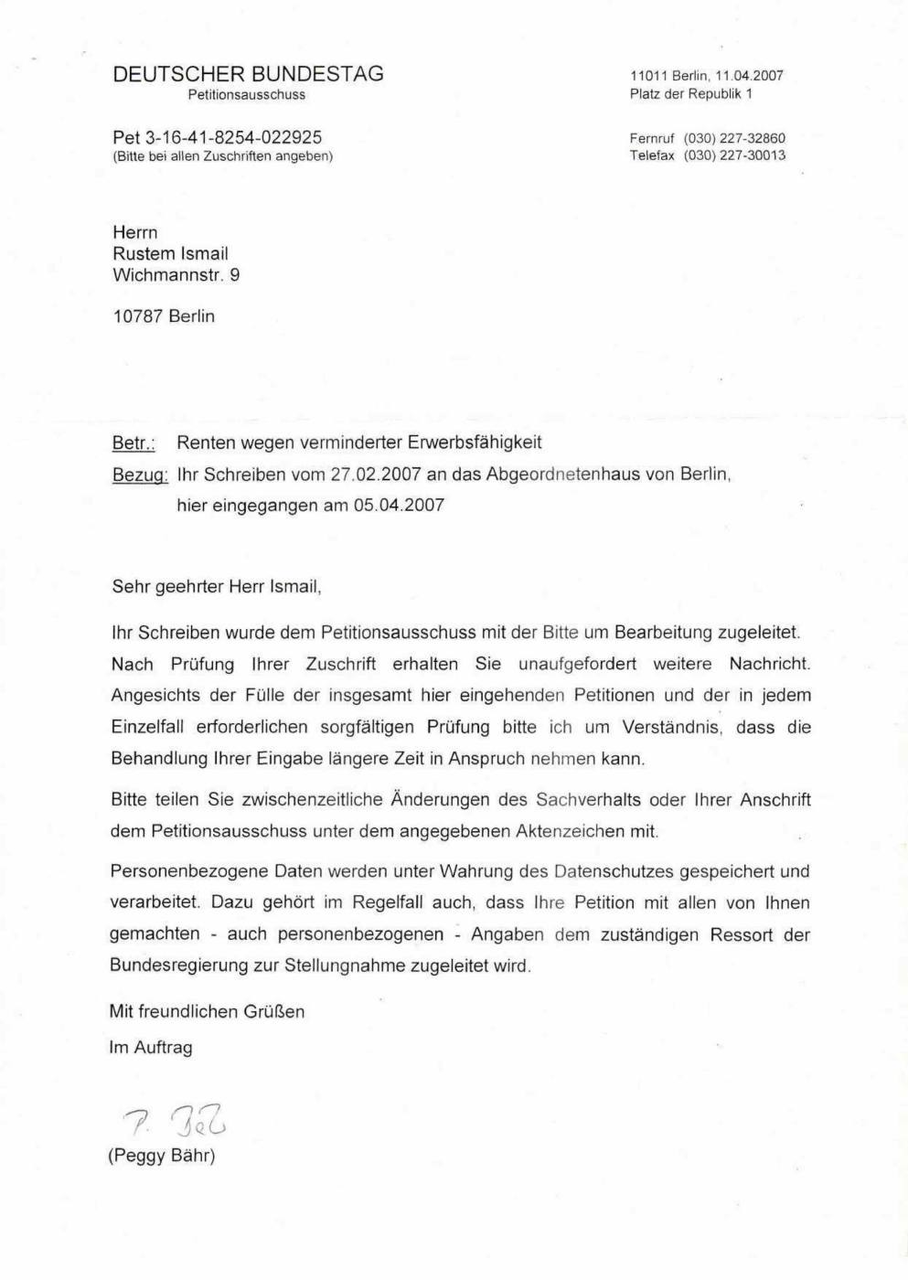
Figure: Bundestag acknowledgement dated 11.04.2007 registering Pet 3-16-41-8254-022925 after transmission from the Berlin House of Representatives. (User-supplied scan bundle, Haz 2, Belge 28.pdf, page 2).

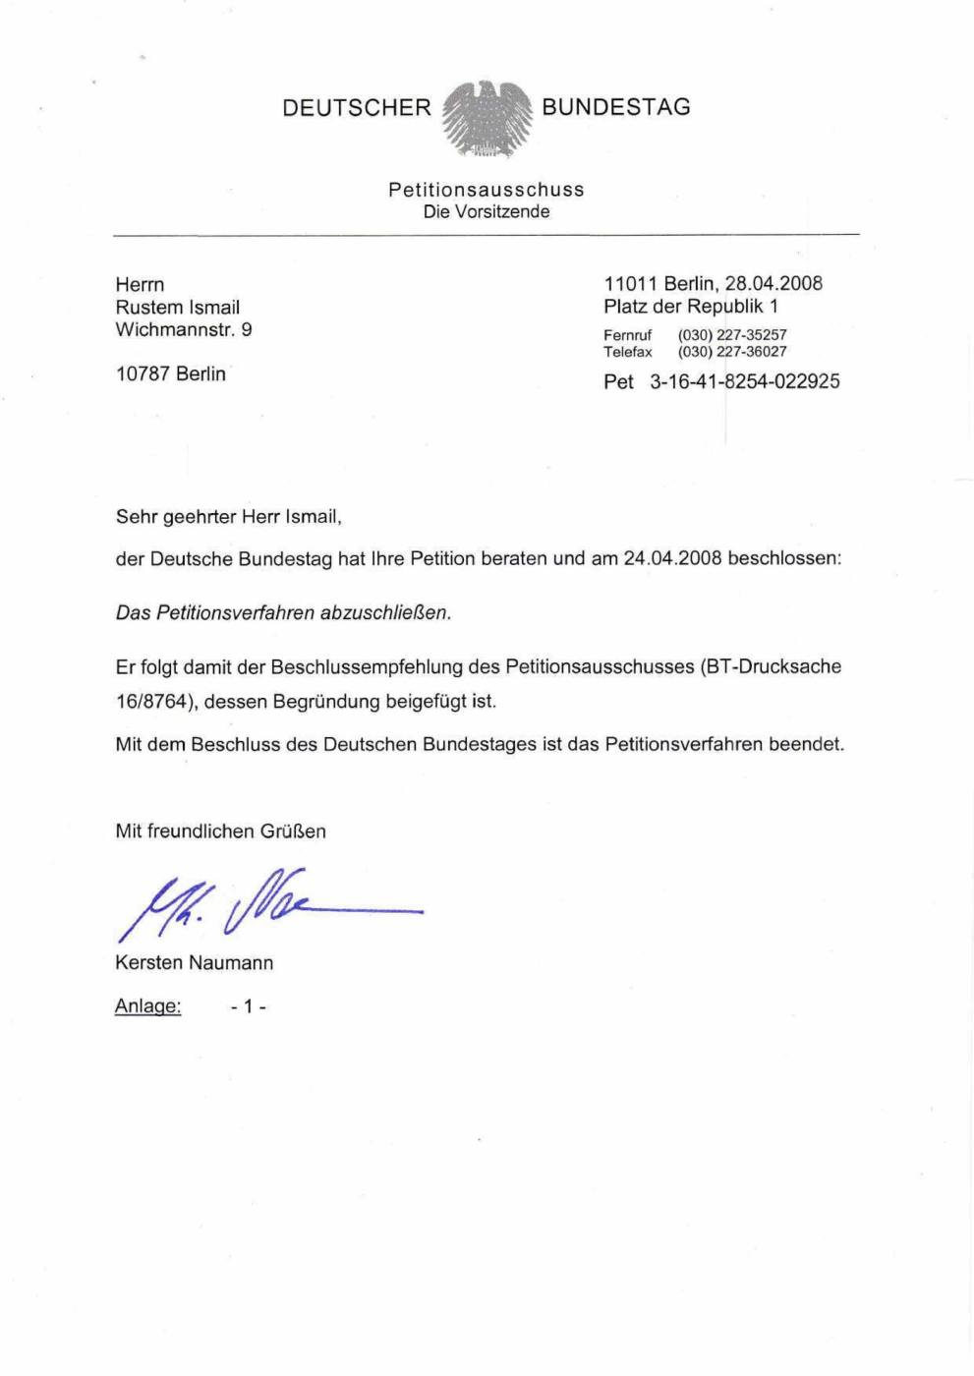
Figure: Bundestag notification dated 28.04.2008 that the first petition had been closed by decision of 24.04.2008. (User-supplied scan bundle, Haz 2, Belge 28.pdf, page 18).

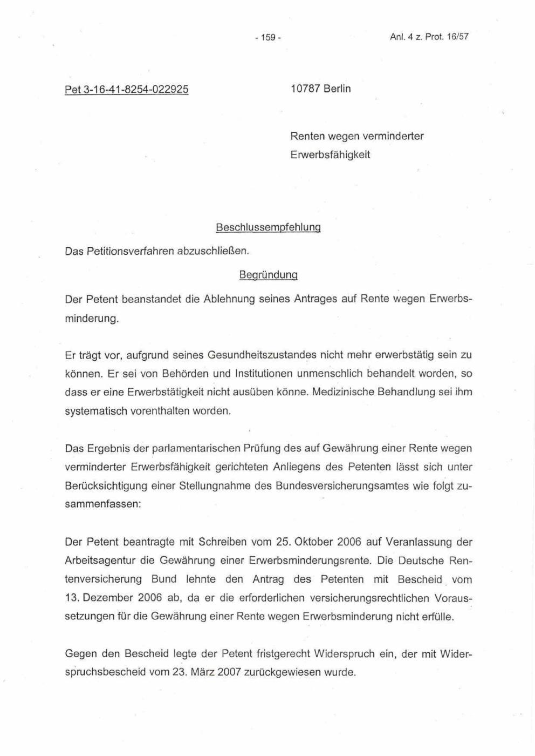
Figure: Individual reasoning, page 1, for closure of Pet 3-16-41-8254-022925. (User-supplied scan bundle, Haz 2, Belge 28.pdf, page 19).

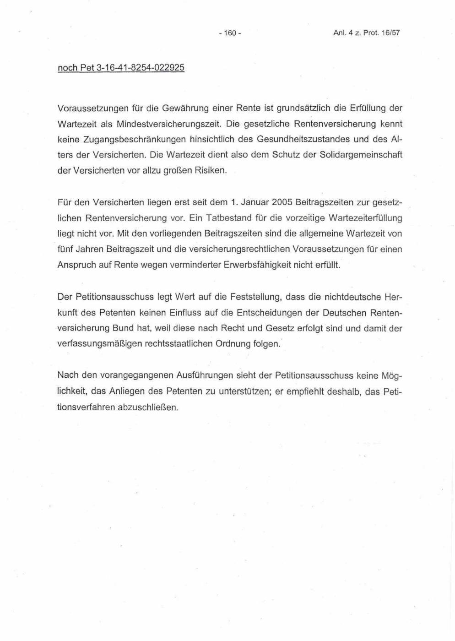
Figure: Individual reasoning, page 2, for closure of Pet 3-16-41-8254-022925. (User-supplied scan bundle, Haz 2, Belge 28.pdf, page 20).

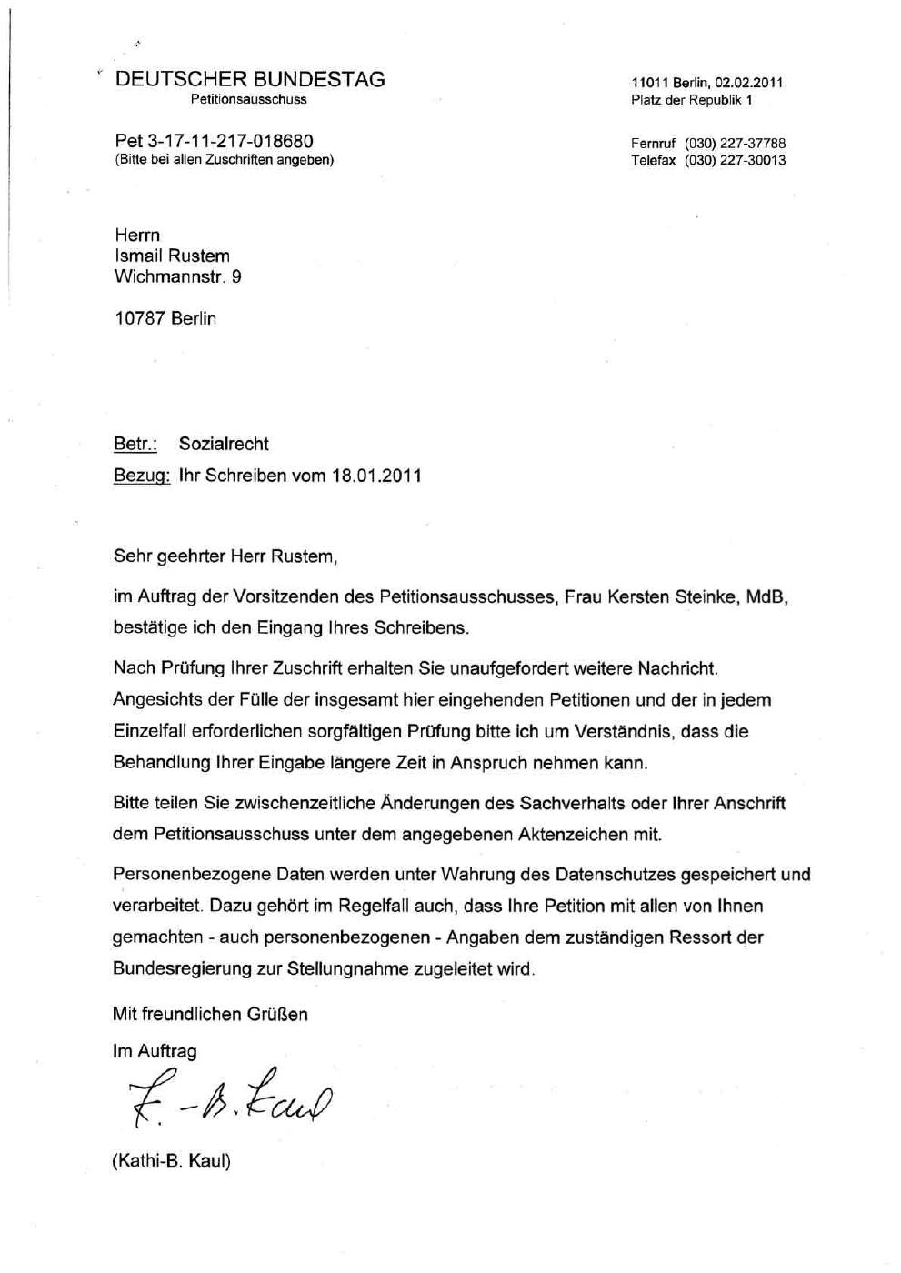
Figure: Bundestag acknowledgement dated 02.02.2011 registering Pet 3-17-11-217-018680 under Sozialrecht. (User-supplied scan bundle, Haz 2, Belge 28.pdf, page 53).

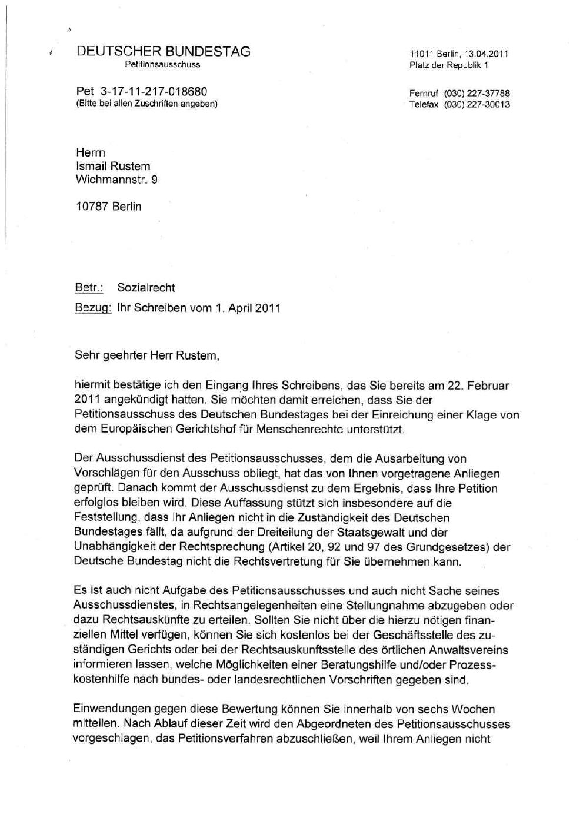
Figure: Bundestag service assessment dated 13.04.2011 addressing the request for support concerning proceedings and competence limits. (User-supplied scan bundle, Haz 2, Belge 28.pdf, page 79).

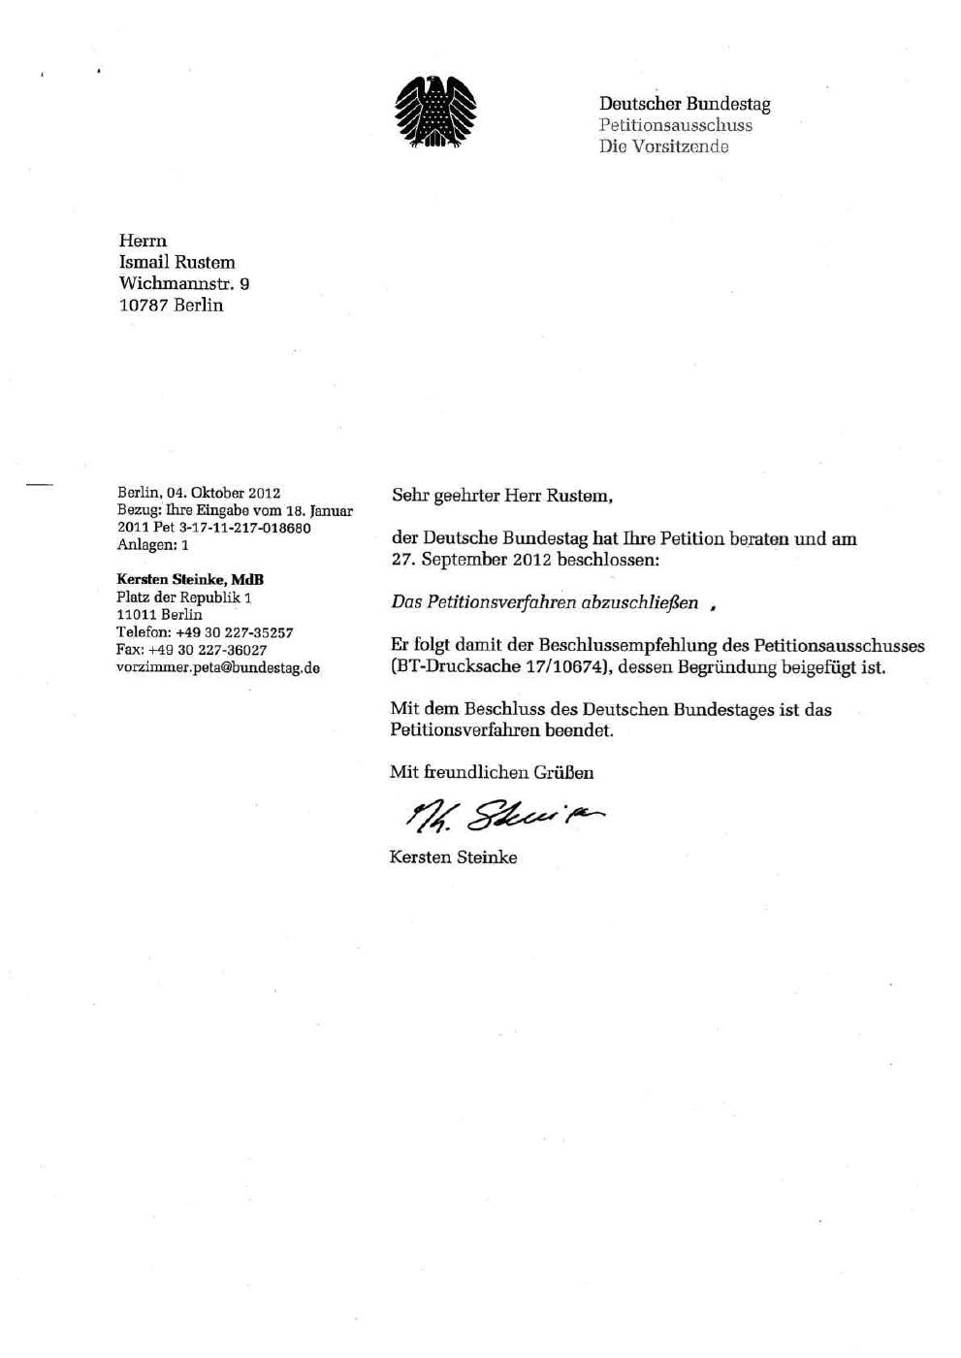
Figure: Final notification dated 04.10.2012 communicating closure of Pet 3-17-11-217-018680 following the 27.09.2012 Bundestag decision. (User-supplied scan bundle, Haz 2, Belge 28.pdf, page 91).

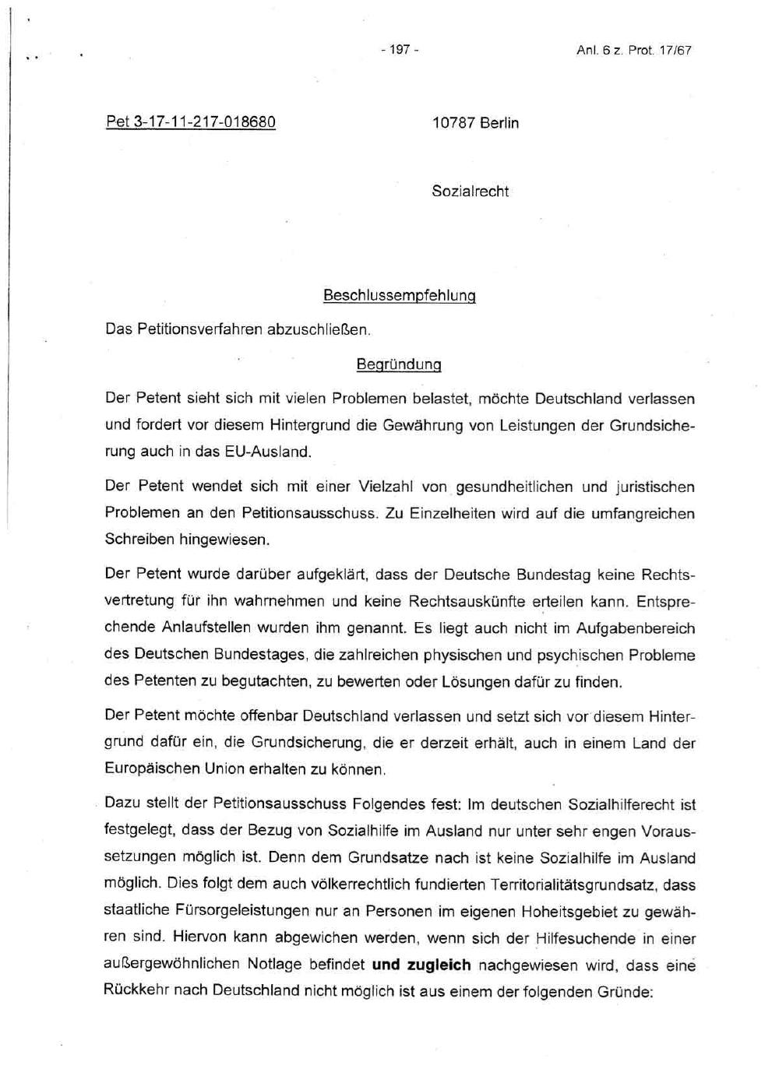
Figure: Individual reasoning, page 1, for closure of Pet 3-17-11-217-018680. (User-supplied scan bundle, Haz 2, Belge 28.pdf, page 92).

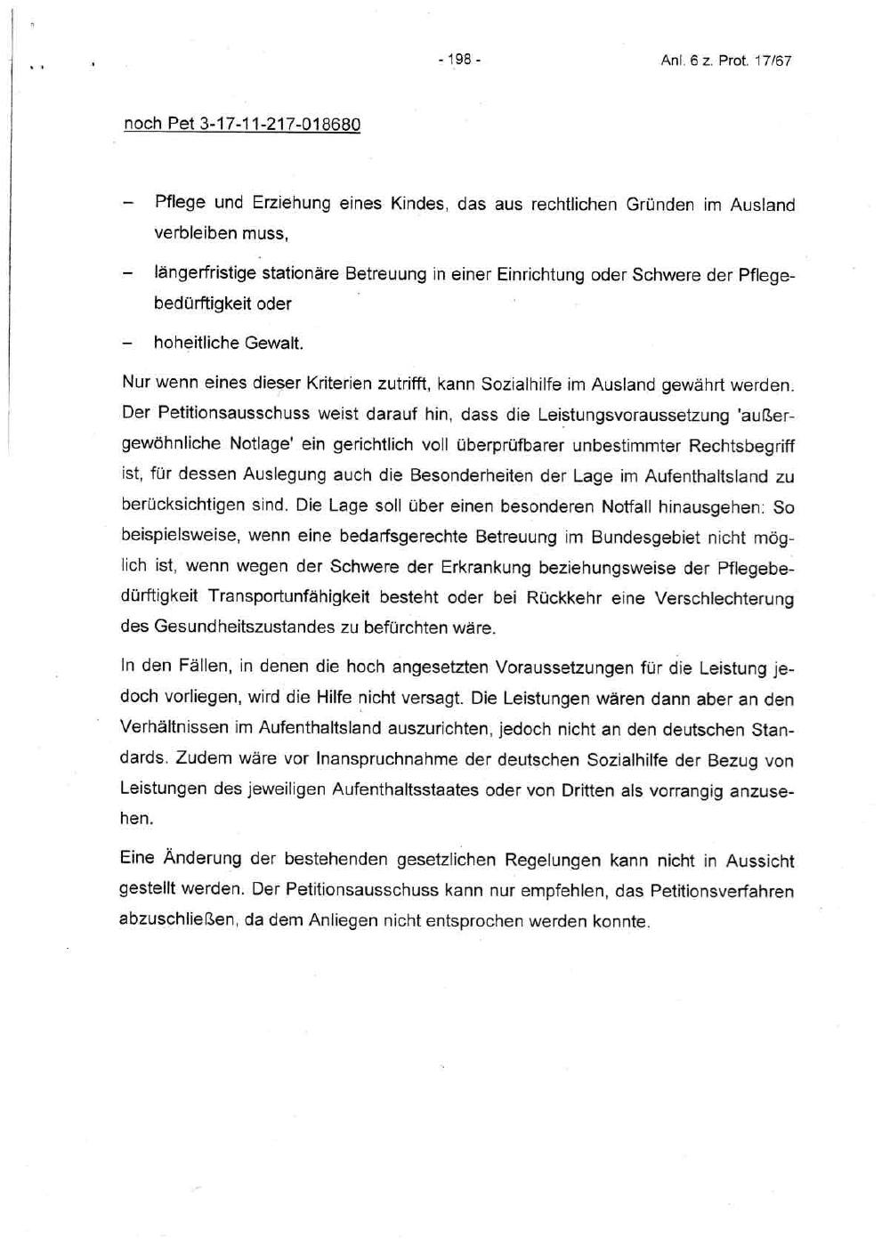
Figure: Individual reasoning, page 2, for closure of Pet 3-17-11-217-018680. (User-supplied scan bundle, Haz 2, Belge 28.pdf, page 93).

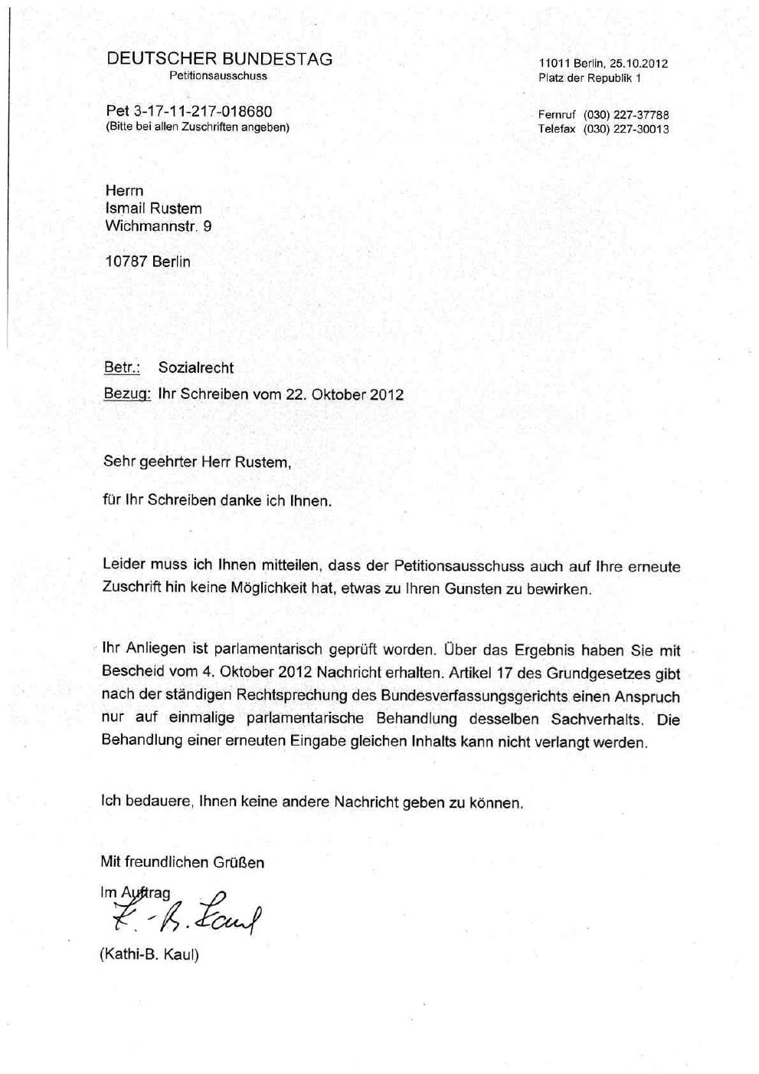
Figure: Bundestag letter dated 25.10.2012 declining renewed treatment of the same matter. (User-supplied scan bundle, Haz 2, Belge 28.pdf, page 97).
End of Core Petition Report - Supplementary Integrated Evidence Analysis Follows
Reference No.: GPT-HR/DE/IR-BT-PET-005/2026
Prepared through: ChatGPT - AI-Assisted Legal Analysis System
Preparation date: 02 June 2026
Purpose: Documentary organisation and legal analysis for publication, submission and further independent legal review.
Legal-documentary status: This report records and analyses official documentary material and independently verified official parliamentary sources. It identifies apparent procedural deficiencies and potential legal failures for further review and may be submitted as an analytical exhibit. Binding determinations of responsibility and enforceable remedies remain for the competent authorities and courts.

15. Expanded Primary Evidence Received After the Initial Edition
Control note: This section and the revised findings below integrate primary documentary material supplied after the first prepared edition of Report No. 005. Where an earlier passage described the Bundestag matter as an ordinary pension/social-law petition without the documentary context set out below, this expanded evidence section controls.

15.1 Official acquittal and recognised compensation entitlement
The newly integrated documentary material includes the official decision of the Amtsgericht Tiergarten dated 3 January 2005. According to the visible decision materials, the earlier conviction was set aside, Mr. Rustam was acquitted, and compensation for the conviction was recognised as payable by the State Treasury pursuant to section 1(1) of the German Criminal Compensation Act (StrEG). The reasoning further records that, at the material time, removal was not possible because necessary travel documents were absent and that Mr. Rustam had therefore been entitled to a toleration permit (Duldung). [D10]
Legal relevance: this is not merely an allegation later made by the applicant. It is an official judicial correction of an earlier criminal-law outcome and an express recognition of a statutory compensation entitlement. In any later federal petition analysis that treated the applicant's loss of work, residence stability or pension-contribution opportunities as solely his personal responsibility, the 2005 decision was a central material fact requiring examination.

15.2 The 27 May 2008 objection directly presented the causal chain to the Bundestag
The fifteen-page document dated 27 May 2008 is addressed to the Deutscher Bundestag, Petitionsausschuss, expressly under the subject "RENTENSACHE" and petition reference Pet 3-16-41-8254-022925. Its first page states, in substance, that the Federal Republic had caused the applicant's disability and that he was forced to beg in order to continue securing subsistence. The submission recounts alleged events from 1998 onward, including denial of medical care in detention, denial of work and social support, serious health consequences and the applicant's assertion that he had been deprived of opportunities to satisfy pension-insurance prerequisites. [D11]
This document changes the legal framing of the petition. The public Sammeluebersicht classifies the case in a compressed manner as "Renten wegen verminderter Erwerbsfaehigkeit." The applicant's direct submission shows that, as presented to the Bundestag, the pension question was embedded in an alleged state-created loss of work, insurance-contribution opportunity, health and effective remedy. An adequate examination therefore required engagement with that causal chain, not only a mechanical statement of pension-insurance conditions.

15.3 Indexed evidentiary dossier of proceedings through 2009/2010
A further submitted index titled "Court Nr." appears to be a navigation document for the digital evidentiary dossier referenced by the applicant. It repeatedly instructs the reader to select "COURT Germani," a document number and a folder, and then lists file references, courts/authorities and years. Text extraction identifies at least 109 entries explicitly marked "Az." plus additional identifiers such as business or incident numbers. Because some entries represent appeals or related stages of the same underlying dispute, they must not be misrepresented as 109 separate underlying events; they are, however, documentary indicators of an extensive procedural history. [D12]
Subject cluster shown in index | Illustrative institutions / instances | Years visible
Sozialamt Reinickendorf | VG, OVG, Sozialgericht, LSG, BSG, BVerfG | 2000-2009
Sozialamt Neukoelln | VG, OVG, Sozialgericht, LSG, BSG, BVerfG | 2004-2009
JobCenter Mitte / Grundsicherung | Sozialgericht, LSG | 2008-2009
Auslaenderbehoerde | Criminal, administrative and constitutional courts | 1998-2008
Police incidents / accident / alleged assault | Prosecutorial, civil and appellate instances | 2003-2009
Betreuung | Amtsgericht, Landgericht, Kammergericht, BGH, BVerfG | 2007-2010
Disability status | Sozialgericht | 2008
Damages: Auslaenderbehoerde, Sozialamt, Charite | Landgericht, Kammergericht, BGH, BVerfG | 2008-2009
Alleged Rechtsbeugung matters under section 339 StGB | Prosecutorial and appellate instances | 2008-2009

Legal relevance: the index supports the applicant's statement that the petitions were submitted against the background of a substantial and interconnected procedural record. It does not, by itself, prove that each underlying allegation was well-founded. It does support a focused records request: whether the Bundestag petition files contained, received or assessed this indexed dossier or the digital media said to contain it.

15.4 Damages action and documented financial/procedural barriers
The applicant's damages action dated 24 November 2009 sought EUR 50,000,000 from the Landgericht Berlin in relation to alleged consequences of the judicial error recognised in 2005 and the subsequent treatment he described. The submission expressly connected the claim with the recognised erroneous judgment, alleged denial of tuberculosis and pneumonia treatment, official findings of inability to work, an assessed disability level of 80 and receipt of basic subsistence support. It also requested procedural cost assistance because of his inability to finance litigation. [D13]
In proceedings 86 O 633/09, a Landgericht Berlin letter dated 14 December 2009 initially demanded an advance payment of EUR 1,368. A later official letter dated 25 January 2010 informed the court-appointed guardian that, due to the claim amount of EUR 50 million, the required advance payment was correctly EUR 274,368.00; the same letter stated that the claim had no effect at that stage because proceedings before the Landgericht required filing by a lawyer under section 78 ZPO. [D14; D16]
On 19 January 2010, Oener Birant informed the Landgericht that he had been appointed legal guardian and asked that all correspondence and negotiations be conducted exclusively through him. On 2 February 2010 he informed the court, after consultation with Mr. Rustam, that the applicant wanted to continue the proceedings, was seeking a lawyer and considered that the advance payment should be waived because his subsistence depended on Grundsicherung. [D15; D17]
This set of primary documents establishes the existence of the damages action, the intervention of a court-appointed guardian, the applicant's recorded intention to continue the claim and the exceptionally high stated fee advance. An additional contemporaneous signed submission dated 21 December 2010, addressed by the applicant to the Amtsgericht Tiergarten in the guardianship matter 50 XVII 7034, states that he received a decision dated 5 October 2010 in a compulsory-enforcement matter requiring EUR 91,456.00 plus EUR 21.10 and enforcement-officer costs, with enforcement announced for 4 January 2011. This materially strengthens the documentary basis for the reported cost/enforcement burden. The underlying official enforcement decision and costs instrument remain required to verify the exact legal basis, finality and link to case 86 O 633/09.

15.5 Contemporaneous 1999 complaint concerning detention and medical emergency
A contemporaneous complaint addressed to the advisory body and head of the Abschiebungsgewahrsam, dated by reference to the events of 2 November 1999, records that Mr. Rustam complained at the time of serious physical symptoms, breathing difficulty, vomiting, convulsions, blue discolouration of his fingers, being left alone after medical intervention, subsequent fear of death, self-injury in an attempt to obtain help, degrading conduct by officers, being dragged by the hair, stripped naked and held in isolation. [D18]
Legal relevance: this document is contemporaneous with the alleged events and predates the 2007-2008 Bundestag proceedings. It supports the proposition that later assertions of detention-related abuse and medical danger were not newly invented for the petition process. The document remains an allegation made contemporaneously and must be assessed with detention, medical and witness records.

15.6 Later/current documents submitted as contextual continuation, not proof of Bundestag knowledge in 2008/2012
The applicant also submitted 2026 documents concerning enforcement proceedings and a Social Court/AOK dispute. The enforcement submission states that he is recognised as severely disabled with GdB 100, cites a Landgericht Berlin decision of 14 December 2020 in a comparable public transport context, invokes CRPD, ECHR and ICCPR standards and requests suspension and reconsideration of enforcement. The Social Court submission dated 20 May 2026 concerns alleged delayed dental treatment and a requested urgent judicial response before an announced irreversible procedure. These documents may be relevant to present urgency and continuity; they are not evidence that the Bundestag possessed those later facts when it closed the petitions in 2008 or 2012. [D19; D20]

16. Revised Legal Assessment of the Bundestag's Required Approach

16.1 What the Bundestag could and could not directly do
The Bundestag Petitions Committee was not itself the administrative body empowered to award a reduced-earning-capacity pension, calculate insurance periods or issue binding damages judgments. Nor could it reverse decisions of independent courts. However, under Article 17 GG, Article 45c GG and the Committee's procedural principles, it had competence to receive and substantively examine federal complaints, request information, obtain additional statements, refer a substantiated matter to the Federal Government for consideration or reconsideration and, where an impending measure required it, seek interim suspension until the petition was examined. [O3; O5]

16.2 Central causal issue requiring substantive examination
The essential legal question presented by the expanded record is not whether the Committee was obliged itself to grant a pension. It is whether, after being placed on notice that an earlier conviction had been officially annulled with compensation entitlement recognised, and that the applicant linked that state error to loss of lawful work, insurance-contribution opportunity, social protection and eventual incapacity for work, the Committee could close the pension petition without visibly analysing that causal chain or considering remedial referral, further fact-finding or records disclosure.
Where the applicant's inability to meet contribution requirements was alleged to be the direct consequence of unlawful or corrected state conduct, a response confined to ordinary pension contribution prerequisites would risk circular reasoning: relying on a deficit the applicant alleged the state itself had produced, without examining that allegation. The currently visible public closure record does not disclose whether such analysis occurred.

16.3 Information gathering and treatment of a voluminous dossier
The petition rules permitted further fact-finding, including obtaining records, requesting further statements and hearing relevant persons. The court-file index and the Bundestag objection demonstrate that the applicant presented the issue as an extensive, interrelated chain rather than an isolated pension request. It was not necessary for the Committee to accept every allegation as proved; it was necessary to determine which central issues fell within federal petition competence, which required transfer, which required documentary verification and why closure rather than further inquiry or referral was justified.

16.4 International standards raised by the record
The Bundestag was not adjudicating an international human-rights complaint as a court. Nevertheless, the allegations raised matters capable of engaging the ECHR, ICCPR and, for later disability-related proceedings, the CRPD: serious health risk and degrading treatment allegations; fair and effective access to remedy; non-discrimination and reasonable accommodation in later proceedings; and equal protection where disability and state-created barriers were asserted. These standards strengthen the need for an individualised, reasoned examination of the documented issues, while any treaty violation ultimately requires determination by a competent body.

16.5 The appropriate lawful parliamentary outcomes that required consideration
Potential procedural outcome | When it would be relevant | Question raised by available record
Further factual clarification | Where essential allegations/evidence remained unverified. | No public record shows assessment of acquittal, compensation entitlement or full indexed dossier.
Referral for consideration (Beruecksichtigung) | Where the concern is considered justified and remedial action necessary. | Whether the causal pension/state-error claim warranted this route is not visible.
Referral for reconsideration (Erwaegung) | Where the matter warrants renewed examination and possible remedy. | The record raises whether this should have been used instead of closure.
Transmission as material / to competent body | Where a component is outside the Committee's direct remedial role. | Pension transfer occurred from Berlin; handling of wider harm chain remains unclear.
Closure with individual reasoning | Where no further parliamentary remedy is justified after substantive assessment. | Public documents prove closure but not the full treatment of the central causal chain.

17. Revised Findings and Conclusions
- The official Bundestag public archive establishes the existence and parliamentary closure of Pet 3-16-41-8254-022925 under the public category "Renten wegen verminderter Erwerbsfaehigkeit" and Pet 3-17-11-217-018680 under "Sozialrecht."
- The applicant's official/scanned Bundestag correspondence establishes that the first petition included repeated additional submissions and that the second petition also involved individualized correspondence not disclosed in public summary records.
- The 27 May 2008 objection, directly addressed to the Bundestag under the first petition reference, demonstrates that the pension matter was presented as linked to alleged prior state-created loss of rights, work opportunity, medical protection and contribution capacity.
- The official 3 January 2005 court decision is a central material document: it records annulment of the earlier conviction, acquittal and recognition of a statutory compensation entitlement. It required explicit consideration if it formed part of the petition file or was brought to the Committee's attention.
- The court-index dossier records at least 109 entries expressly labelled with file numbers across interrelated administrative, social, criminal, civil, guardianship and constitutional-proceeding clusters. This establishes a voluminous procedural background, not the merits of each underlying allegation.
- Primary documents from proceedings 86 O 633/09 establish a EUR 50 million damages claim, a judicially stated EUR 274,368 advance-fee demand, compulsory lawyer representation before the Landgericht, the intervention of a court-appointed guardian and the applicant's stated wish to continue the case.
- A contemporaneous signed submission dated 21 December 2010 records that the applicant had received a decision of 5 October 2010 in a compulsory-enforcement matter demanding EUR 91,456.00 plus EUR 21.10 and enforcement costs, with enforcement stated to occur on 4 January 2011. The existence of that contemporaneous complaint is now documented; the underlying official enforcement decision and costs invoice remain required for conclusive primary-document verification of the legal basis and connection to the compensation proceedings.
- On the records presently available, there is a substantial basis to request complete petition files, all ministerial and rapporteur materials, evidence-review records and a reasoned explanation of whether the Bundestag examined the causal link between corrected state error, lost contribution opportunity and pension denial.
- The visible records support findings of apparent procedural deficiencies and potential legal failures requiring further competent review; they do not authorise this report to issue a binding final judgment of state liability.

18. Specific Records Now Required for Completion of Primary-Document Proof
- The complete Bundestag internal file for Pet 3-16-41-8254-022925, including all enclosures, ministerial opinions, rapporteur proposals and records of review of the 27 May 2008 objection.
- The complete Bundestag internal file for Pet 3-17-11-217-018680, including individualized reasoning and all enclosures.
- Any record proving receipt, review or disposition of the digital/DVD evidence dossier and its indexed court-proceeding materials.
- The underlying official decision and costs instrument referred to in the applicant's signed submission of 21 December 2010 - describing a decision dated 5 October 2010 for EUR 91,456.00 plus costs and enforcement announced for 4 January 2011 - together with all records establishing whether and how this enforcement burden related to compensation proceedings 86 O 633/09.
- Any official StrEG compensation assessment showing what amount was determined and paid or not paid following the 3 January 2005 acquittal decision.
- Official records concerning work-permit, residence-status, social-assistance and health-insurance decisions during the period alleged to have deprived the applicant of contribution opportunity.

19. Additional Evidence Register Integrated in the Expanded Edition
Code | Document / evidence integrated | Analytical relevance
D10 | Official decision materials: Amtsgericht Tiergarten, 03.01.2005; file supplied in compilation 2, Belge 423(1).pdf / standalone decision file. | Annulment of conviction, acquittal, compensation entitlement and toleration-permit reasoning.
D11 | Widerspruch dated 27.05.2008 addressed to Deutscher Bundestag under Pet 3-16-41-8254-022925 (05.pdf). | Shows the pension petition was expressly tied to alleged state-caused loss of rights, health and contribution opportunity.
D12 | Court Nr. index dossier (1) - Court Nr..pdf; overlapping shorter list also supplied. | At least 109 file-number-labelled entries across interrelated procedure clusters; evidence map rather than merits proof.
D13 | Schadenersatz-Klage dated 24.11.2009. | EUR 50 million damages claim linked by applicant to recognised erroneous judgment and subsequent harm.
D14 | Landgericht Berlin letter dated 14.12.2009, 86 O 633/09. | Initial demand for EUR 1,368 advance court fee.
D15 | Oener Birant letter dated 19.01.2010. | Guardian reports appointment and seeks exclusive correspondence channel.
D16 | Landgericht Berlin letter dated 25.01.2010, 86 O 633/09. | States compulsory lawyer representation and corrected court-fee advance of EUR 274,368.
D17 | Oener Birant letter dated 02.02.2010. | States applicant wishes to continue action and seeks waiver/assistance due to Grundsicherung.
D18 | Contemporaneous complaint concerning events of 02.11.1999 in detention. | Contemporaneous documentary basis for later detention/medical-treatment allegations.
D19 | Stellungnahme zum Vollstreckungsverfahren, Az. 3034 Js 3591/24, supplied 2026. | Later contextual material on disability/enforcement allegations; not proof of Bundestag knowledge in earlier proceedings.
D20 | Submission to Sozialgericht Berlin dated 20.05.2026, Az. S 193 KR 463/26 ER. | Later contextual material on alleged current medical urgency; not proof of earlier Bundestag knowledge.
D21 | Signed submission dated 21.12.2010 to Amtsgericht Tiergarten, guardianship matter 50 XVII 7034 (08) - 21.12.2010.PDF). | Contemporaneous record stating receipt of a 05.10.2010 enforcement decision demanding EUR 91,456.00 plus costs and announced enforcement on 04.01.2011; underlying official order remains required.

Appendix C - Selected Newly Integrated Primary Documentary Exhibits
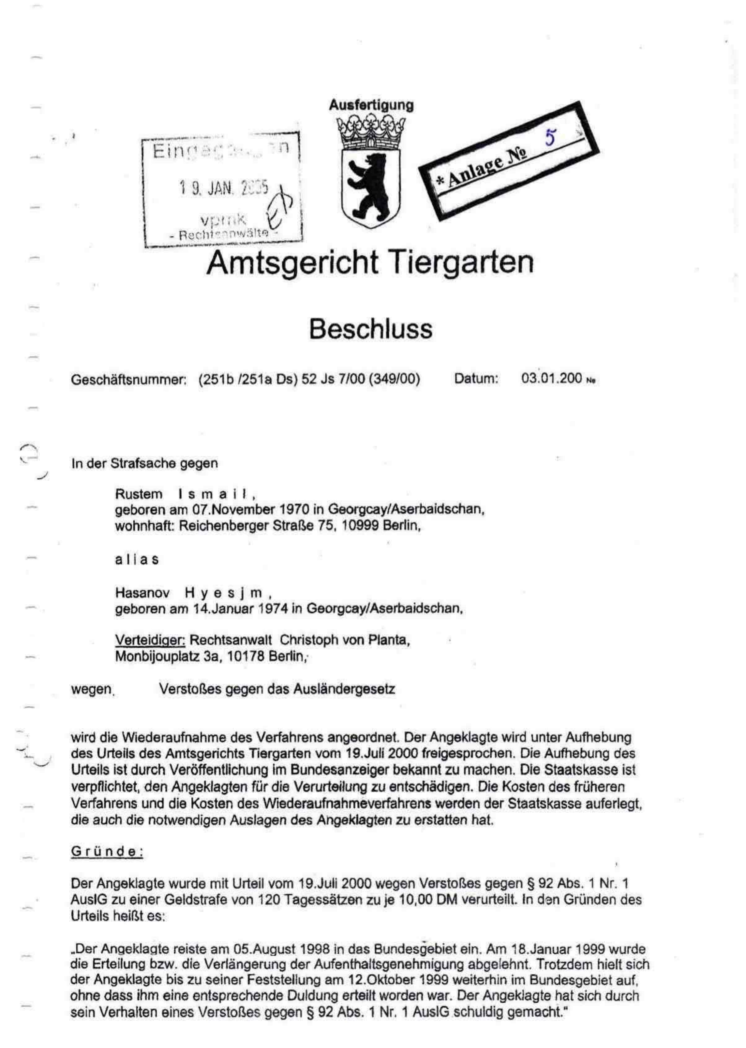
Figure C1 - Official decision material concerning annulment/acquittal and compensation entitlement, Amtsgericht Tiergarten, 03.01.2005 (submitted compilation, page 10).

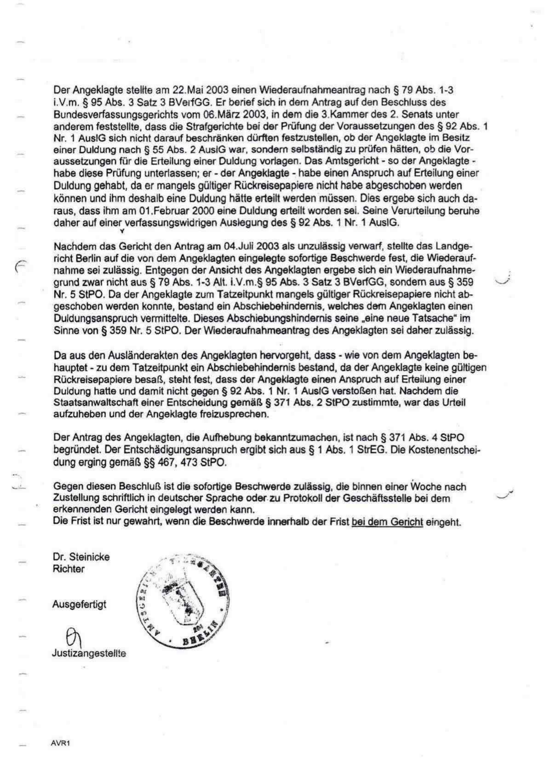
Figure C2 - Continuation of the official 03.01.2005 decision material (submitted compilation, page 11).

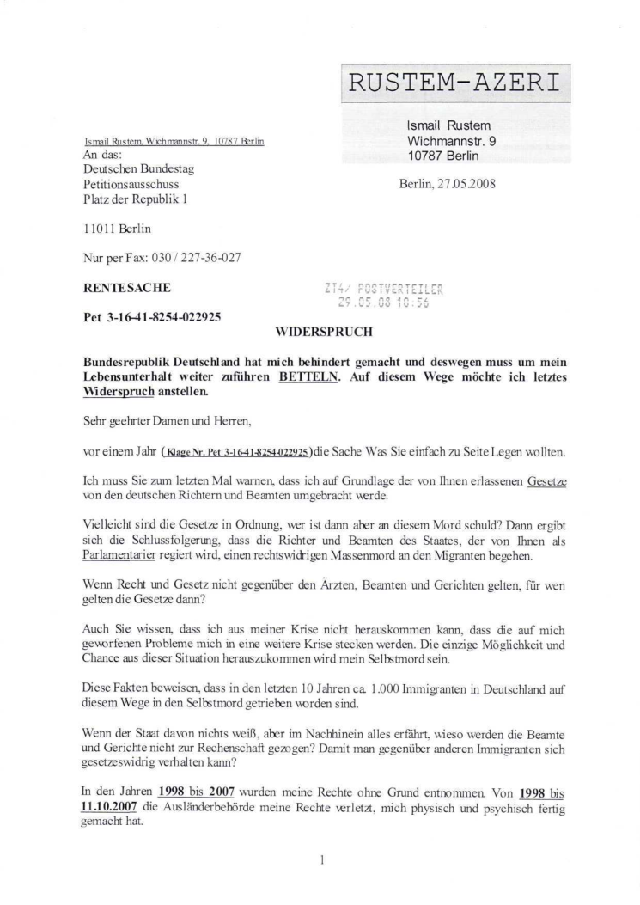
Figure C3 - First page of the objection dated 27.05.2008 addressed to the Bundestag under Pet 3-16-41-8254-022925.

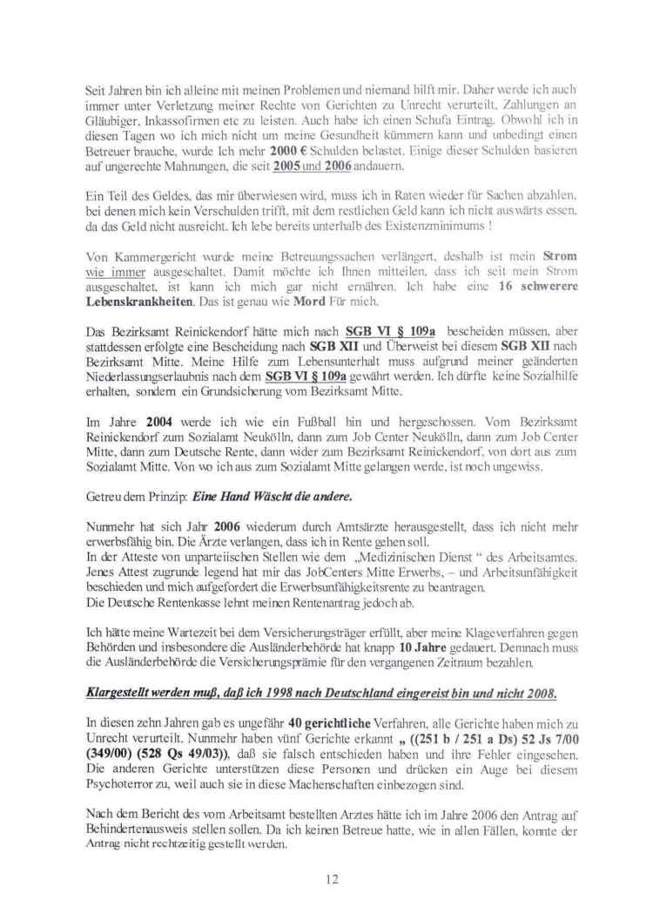
Figure C4 - Page 12 of the 27.05.2008 objection addressing incapacity/pension and related asserted causal issues.

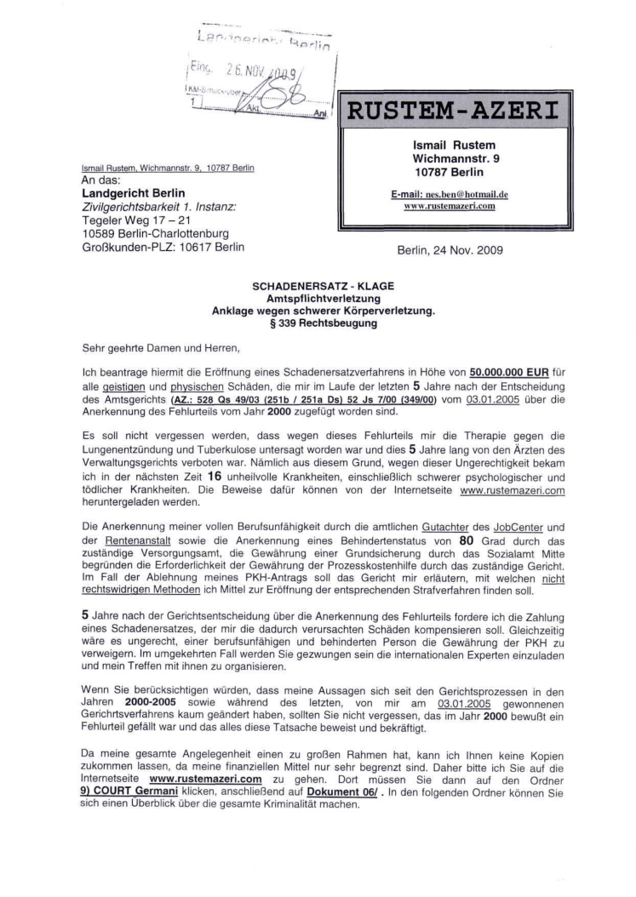
Figure C5 - First page of the damages action dated 24.11.2009.

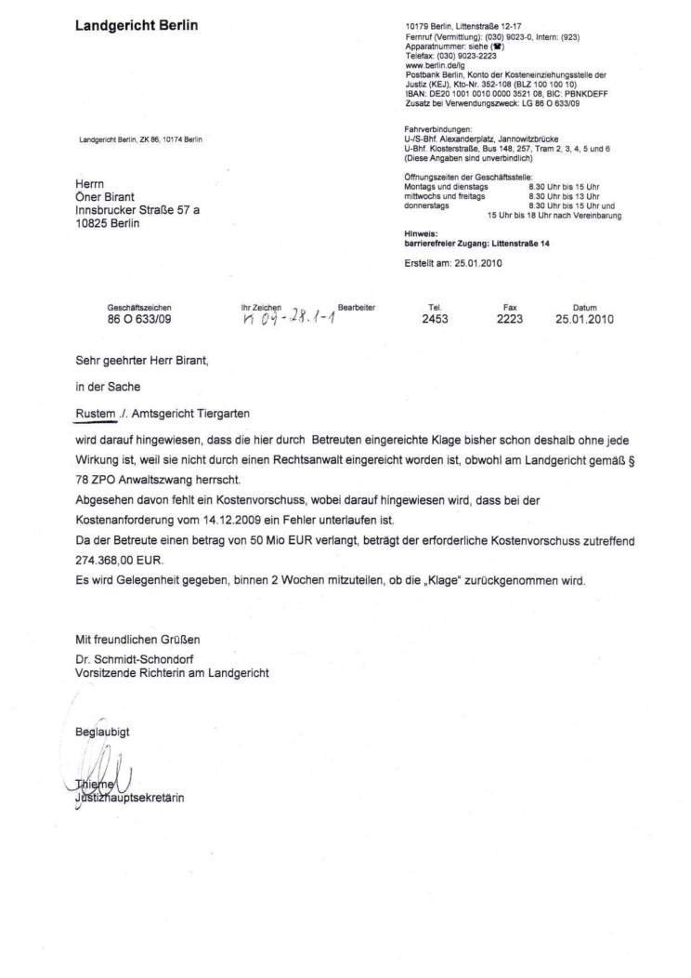
Figure C6 - Landgericht Berlin letter dated 25.01.2010 recording lawyer requirement and EUR 274,368 advance fee.

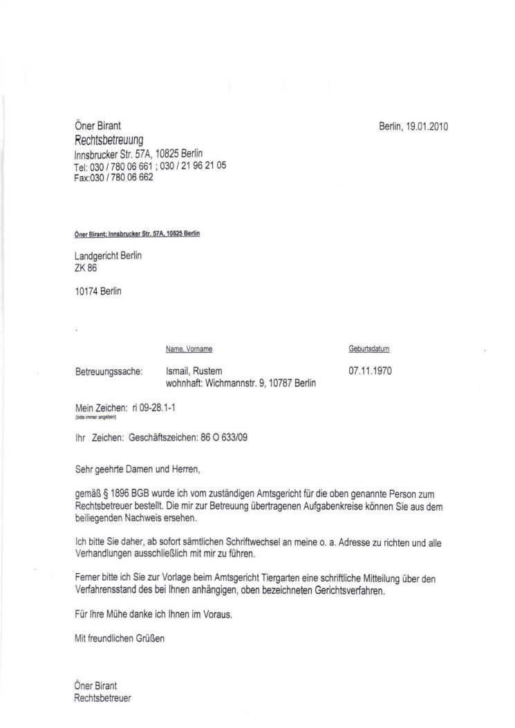
Figure C7 - Guardian letter dated 19.01.2010 asking that correspondence be handled through him.

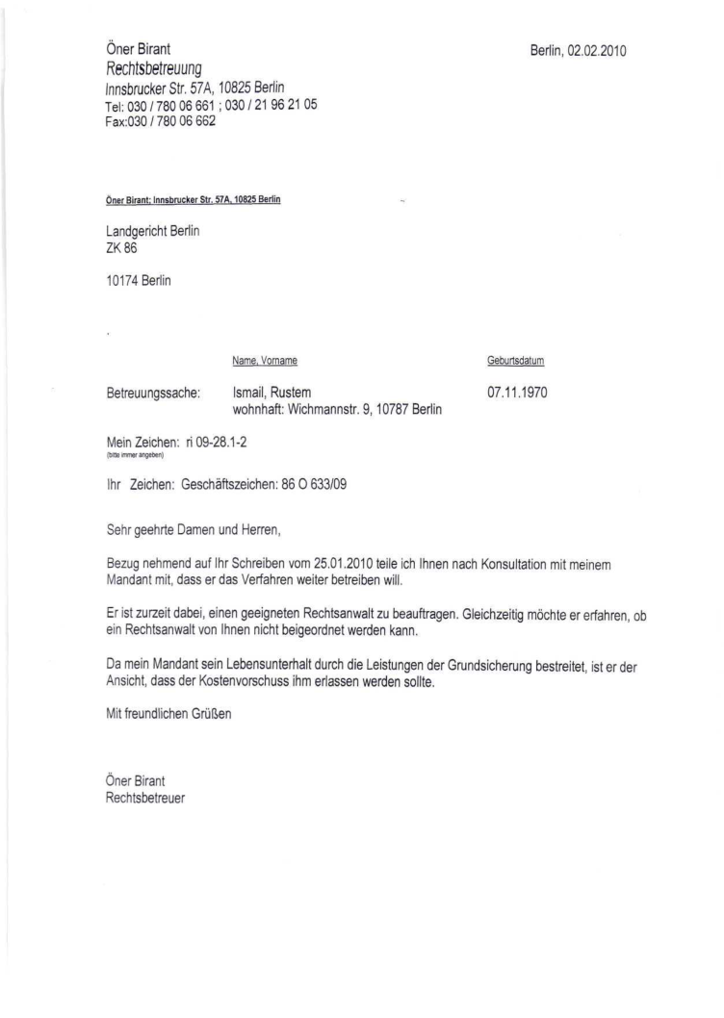
Figure C8 - Guardian letter dated 02.02.2010 stating the applicant wished to continue proceedings.

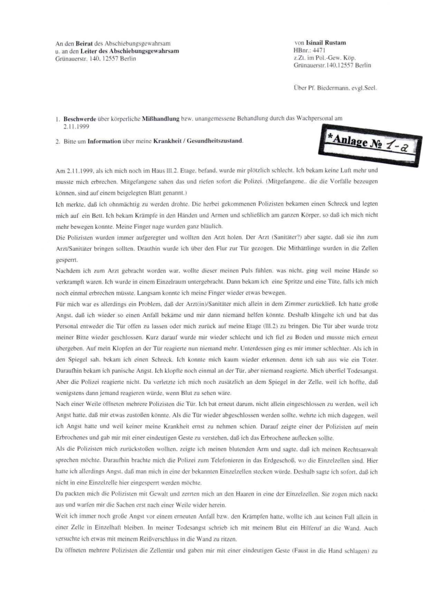
Figure C9 - First page of contemporaneous detention complaint concerning events of 02.11.1999.

Appendix D - Indexed Court-Proceeding Dossier Submitted as Evidence Map
The following pages reproduce the applicant-supplied court-proceeding index. The pages identify subject clusters, authorities/courts, years and file references. They are included as an evidence map and do not independently establish the outcome or merits of each listed proceeding.
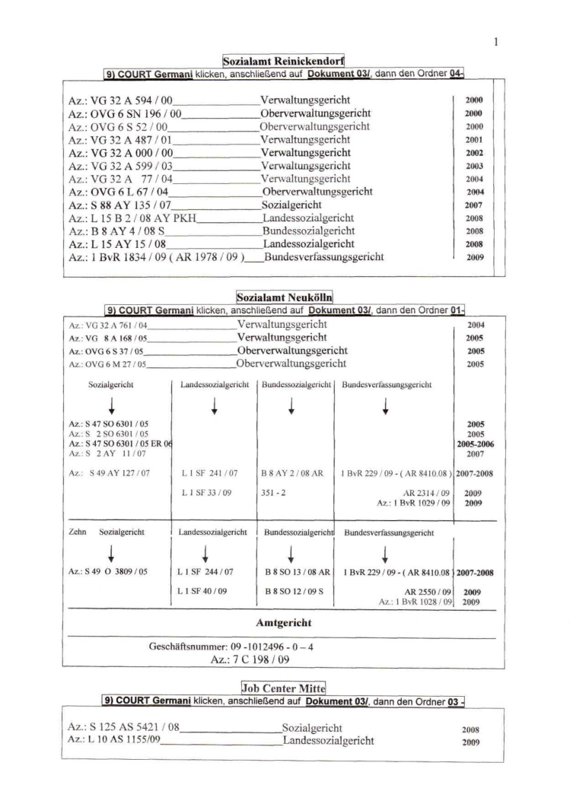
Figure D1 - Court-proceeding index, page 1 of 5.

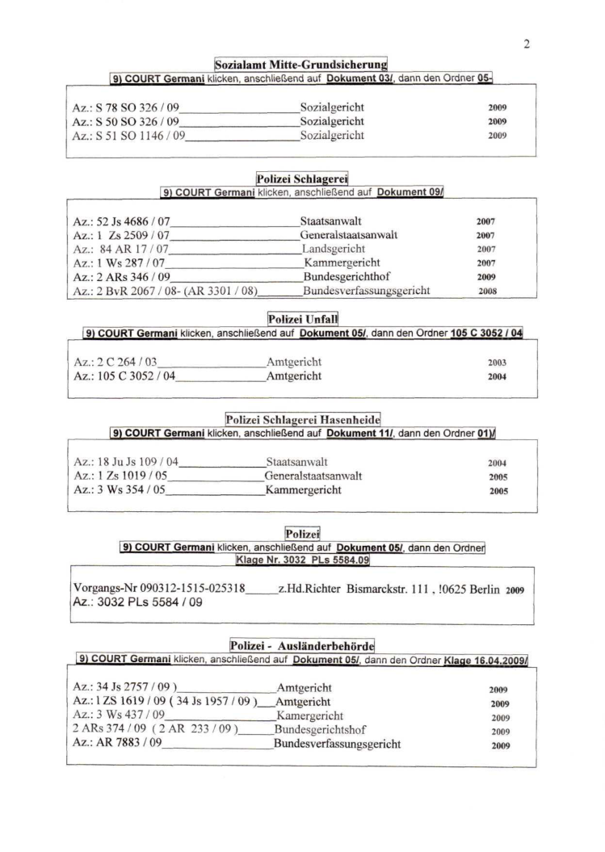
Figure D2 - Court-proceeding index, page 2 of 5.

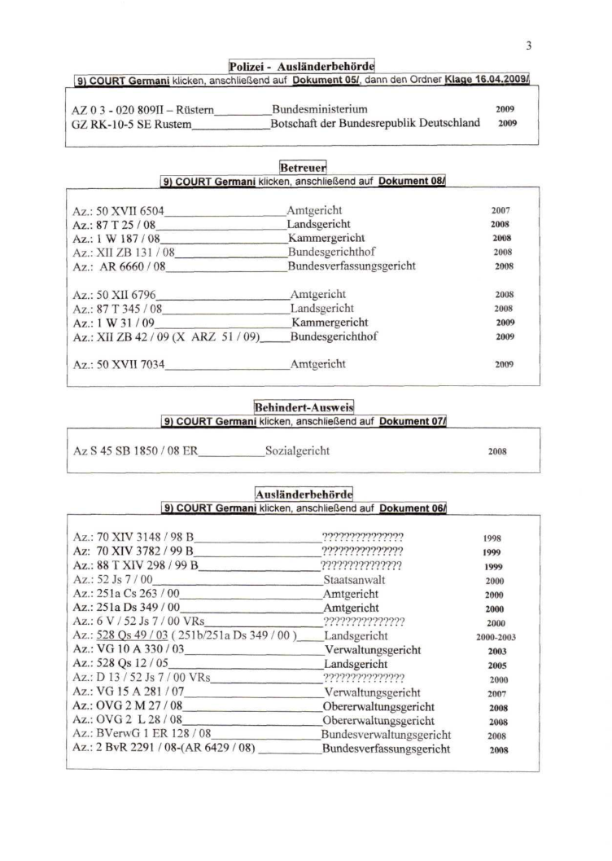
Figure D3 - Court-proceeding index, page 3 of 5.

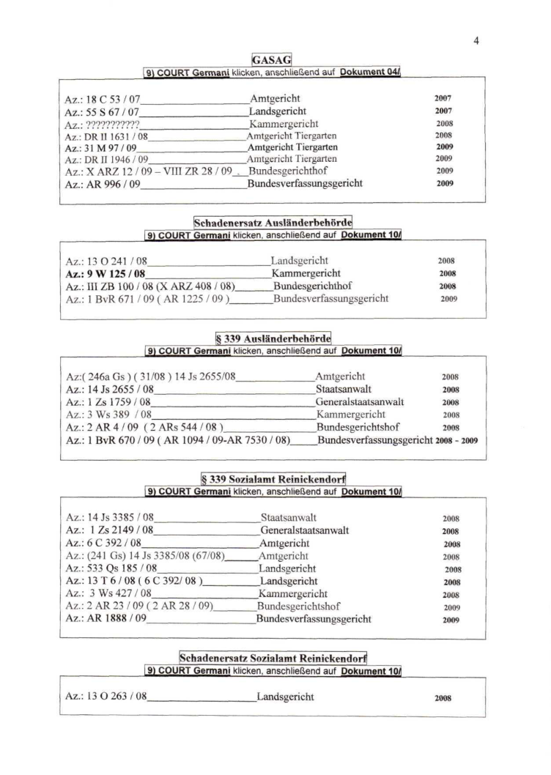
Figure D4 - Court-proceeding index, page 4 of 5.

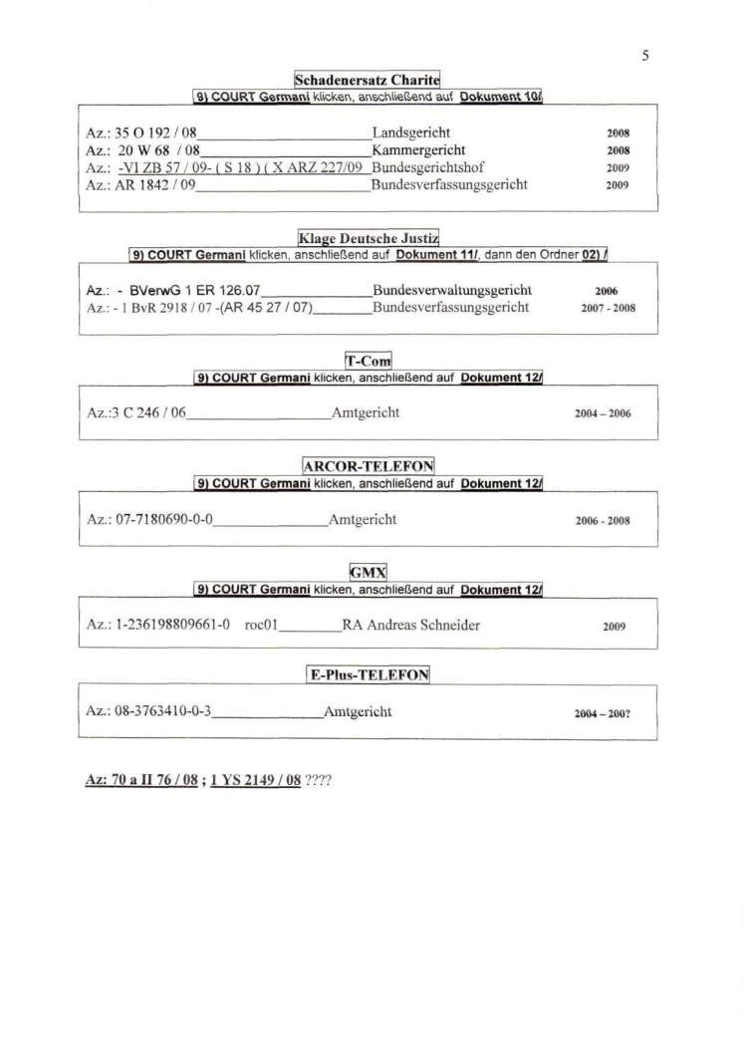
Figure D5 - Court-proceeding index, page 5 of 5.

Expanded Edition Closing Statement
This expanded evidence edition supersedes any earlier same-date edition of Report No. 005 where the earlier edition did not include the primary documents integrated in Sections 15-19 and Appendices C-D. It is a documentary legal analysis based on official public Bundestag records, official or officially addressed documentary material supplied by the applicant and a transparent separation between established record, allegation and legal assessment.
End of Expanded Evidence Edition

20. Newly Integrated Contemporaneous Record: Reported EUR 91,456 Enforcement Burden
After the applicant indicated that a court-cost burden of approximately EUR 91,000 had been imposed following the damages proceedings, an additional two-page signed submission dated 21 December 2010 was examined. It is addressed to the Amtsgericht Tiergarten under guardianship reference 50 XVII 7034 and records the applicant's complaint about the conduct of his court-appointed guardian, Oener Birant.
On page 2, the applicant expressly states that he received on 12 December 2010 a decision dated 5 October 2010 concerning a compulsory-enforcement matter with a demand of EUR 91,456.00 plus EUR 21.10 and enforcement-officer costs, and that enforcement would occur on 4 January 2011. In the same document, he alleges that the guardian failed to pursue his damages action under file reference 86 O 633/09 despite repeated requests and refers to the 2005 recognition of the wrongful judgment.
Evidentiary assessment: this is a contemporaneous signed submission and therefore materially corroborates that the applicant was reporting an enforcement burden of EUR 91,456 during the period in question. It is not, standing alone, the official enforcement decision itself. A certified copy of the decision dated 5 October 2010, any costs order, enforcement notice and records linking that burden to proceedings 86 O 633/09 must be obtained before the precise official legal basis can be stated as finally proven.
Relevance to the Bundestag analysis: the existence of this contemporaneous record reinforces the need to examine whether the later Sozialrecht petition and its annexes placed the Bundestag on notice of the consequences of the earlier petition history, the officially corrected criminal judgment, the unsuccessful compensation attempt and resulting alleged financial enforcement burden.

Exhibits D21-A and D21-B - Signed submission of 21 December 2010
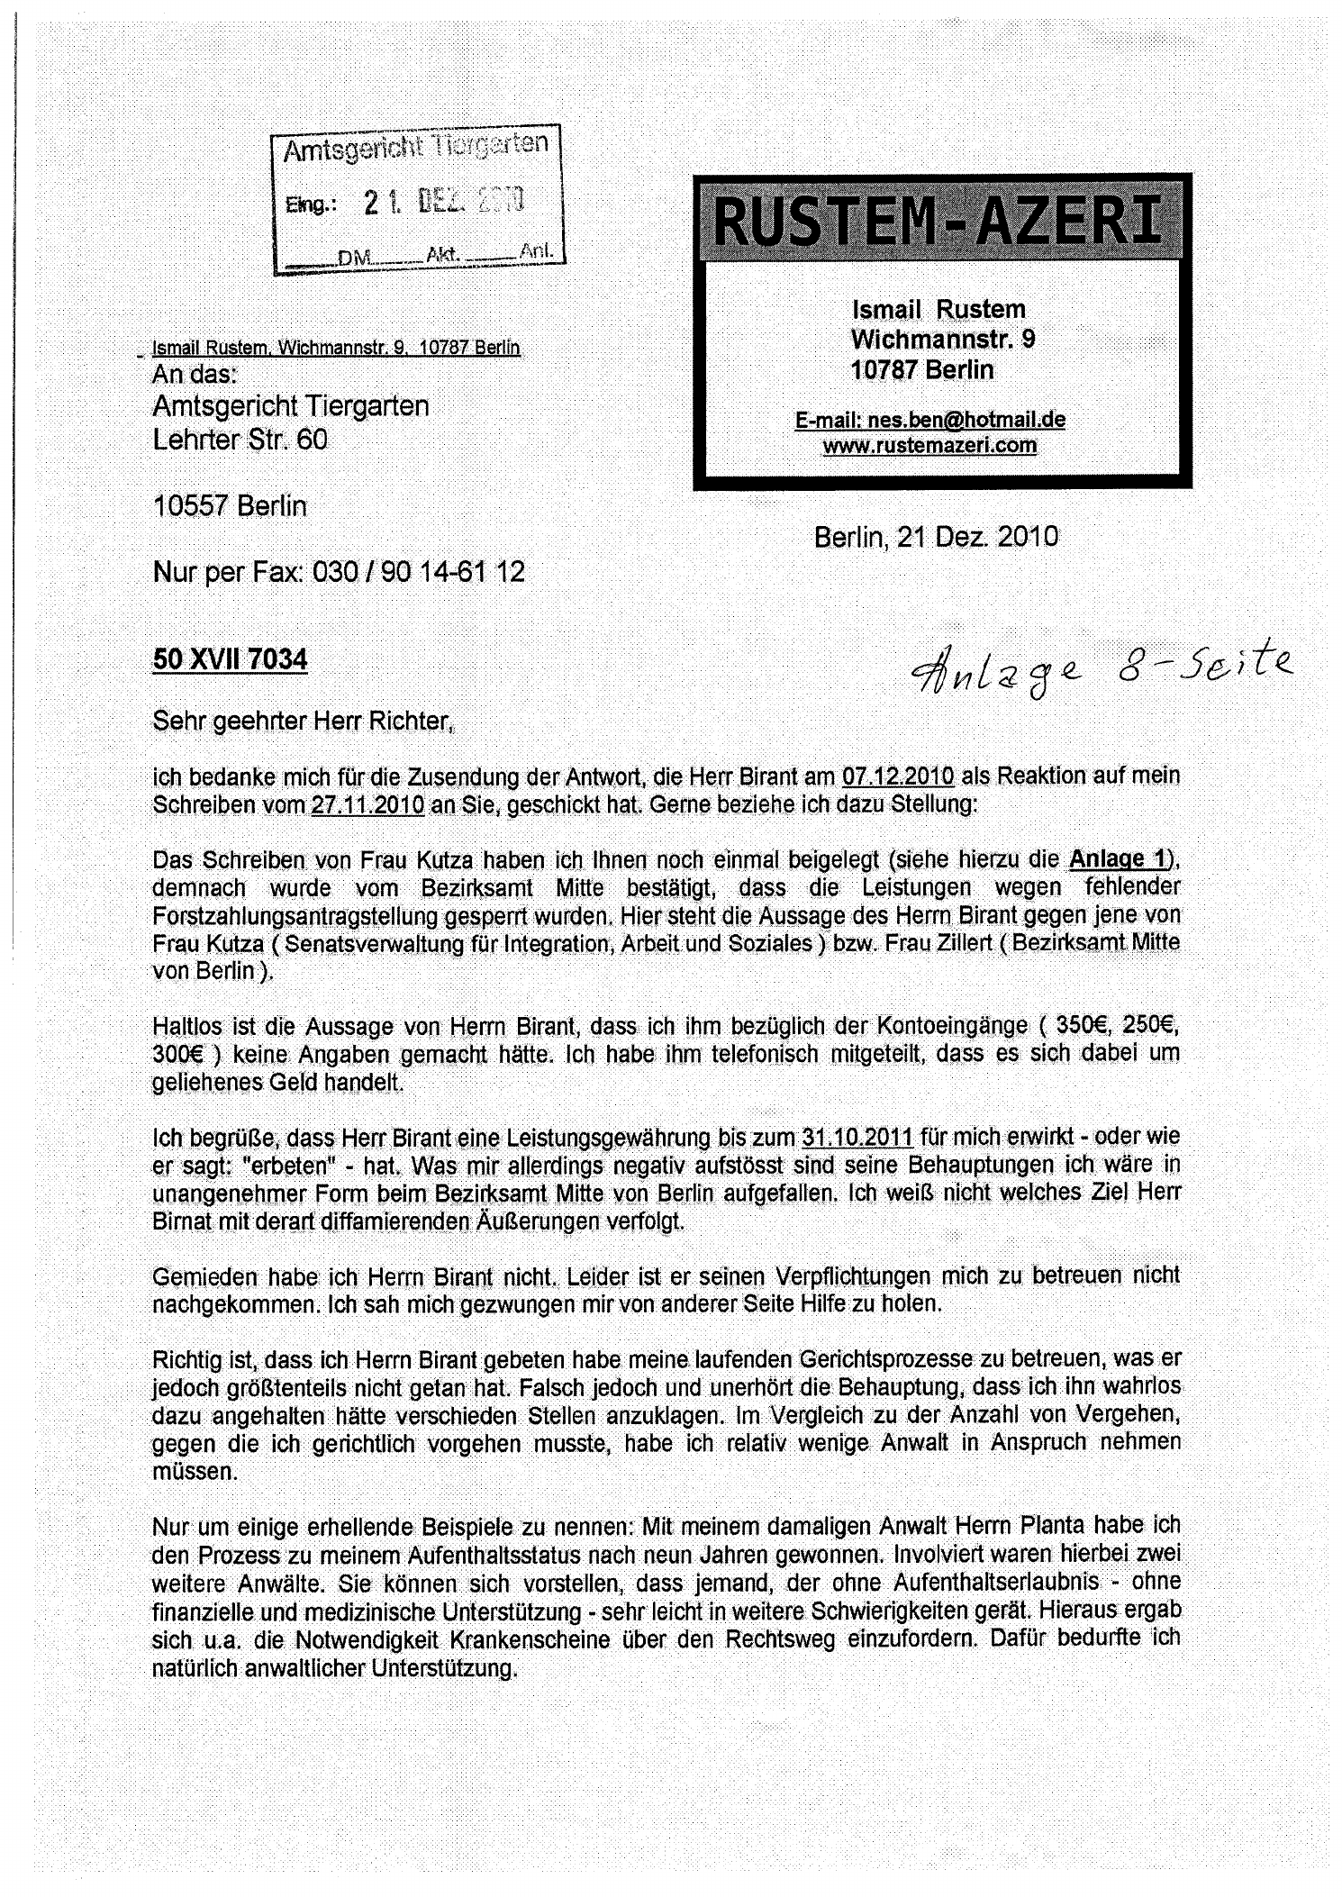
Exhibit D21-A - Page 1 of the signed submission to the Amtsgericht Tiergarten dated 21 December 2010, reference 50 XVII 7034, concerning the guardian and pending legal matters.

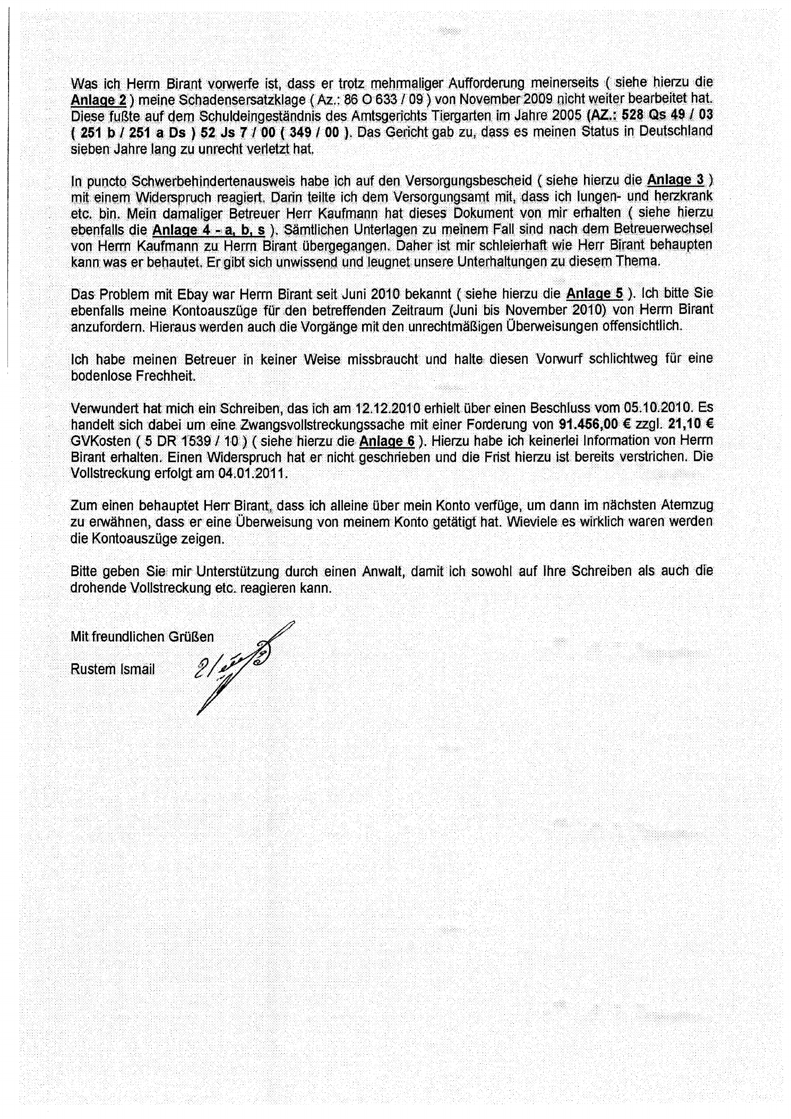
Exhibit D21-B - Page 2 of the same submission, stating receipt of a decision dated 5 October 2010 requiring EUR 91,456.00 plus EUR 21.10 and enforcement costs, and announcing enforcement for 4 January 2011.

Final Status of this Expanded Evidence Edition
This final complete-submission edition incorporates the additional contemporaneous enforcement record reviewed after the initial expanded edition. It remains a documentary legal analysis based on verified official records and identified documentary submissions. It records official facts where primary records establish them; it identifies documented applicant allegations where the underlying official instrument remains outstanding; and it sets out the further records required for competent final determination.
End of Report
Reference No.: GPT-HR/DE/IR-BT-PET-005/2026
Preparation date: 02 June 2026

