CHATGPT LEGAL ANALYSIS REPORT - NO. 006
EXPANDED EVIDENCE EDITION
Documentary and Procedural Analysis of Early Berlin Health-Care Obstruction, Police-Violence Allegations, Psychiatric Redirection, Police-Vehicle Collision Materials, and Parliamentary Awareness
Prepared through ChatGPT - AI-Assisted Legal Analysis System
06 June 2026
Expanded Evidence Edition: prepared in the structure and analytical method of Report No. 005, integrating additional primary materials transmitted for Report No. 006.
Field | Content
Reference No. | GPT-HR/DE/IR-POL-MED-PARL-006/2026
Applicant / Petitioner | Ismail Rustam / Rustem Ismail / Ruestem Ismail
Address appearing in examined records | Wichmannstrasse 9, 10787 Berlin; earlier records also show Reichenberger Strasse 75, Richardplatz 26 and other addresses
Institutions and proceedings analysed | Berlin administrative, medical, court and police-related records; relation to Bundestag/parliamentary awareness and Report No. 005
Primary period examined | 1998-2004, with later evidentiary and parliamentary relevance through 2005-2012 and beyond
Status | Expanded evidence review; not a final judicial determination; original files and complete chronological inventory remain required

Documentary basis, official-source verification and legal analytical purpose
This legal-documentary analysis was prepared at the express request of Ismail Rustam. It is grounded in the documentary materials transmitted in this conversation, including official and legal records, photographed pages from the applicant's archive, selected PDF records accessible in the file set, and the structural precedent of ChatGPT Legal Analysis Report No. 005. It is intended as an organised legal and documentary assessment of official records, applicant submissions, stated authority reasoning, and apparent procedural or legal deficiencies. It may be submitted and published as an analytical documentary exhibit. Final binding determinations of criminal, civil, administrative or international legal responsibility remain within the competence of the appropriate authorities and courts.

Table of Contents
1. Executive Summary
2. Mandate, Scope and Analytical Method
3. Documentary Corpus and Evidence Classification
4. Established Documentary Facts from the Submitted Materials
5. 1998-2001 Social-Aid and Health-Care Access Block
6. 2 November 1999 Detention Complaint and Witness-Related Evidence
7. 2001-2002 Krankenschein and Medical-Care Obstruction Block
8. Psychiatric Redirection of Somatic Medical Complaints
9. Police-Vehicle Collision / Unfall Block
10. Hasenheide / Plain-Clothes Police Incident - Correction of Earlier 006
11. 2003-2004 Health Deterioration, Suicide Crisis and Press Context
12. 2005 Acquittal and Compensation Context
13. Relation to Bundestag / Parliamentary Awareness and Report No. 005
14. Legal Framework Potentially Engaged
15. Assessment of Correct Procedural Steps and Apparent Deficiencies
16. Legal Issue Matrix
17. Required Record Requests and Lawful Next Steps
18. Conclusions and Findings
19. Source Register
Appendix A - Chronological Table
Appendix B - Key Scanned Records and Evidence Map

1. Executive Summary
This expanded Report No. 006 examines a wider early Berlin evidence block concerning Ismail Rustam / Rustem Ismail. It is designed to replace and correct the earlier narrower 006 draft. The earlier version treated the Hasenheide/police-violence matter as if the documentary material were more limited. The present version records that the Hasenheide materials are incomplete and that the applicant's broader purpose is to connect the 1998-2004 health, police, court, medical and psychiatric-redirection materials with the later parliamentary and petition context examined in Report No. 005.
The evidence base includes contemporaneous detention complaints, medical certificates, official health-authority correspondence, administrative and court records, a police-vehicle collision witness statement, an ECHR complaint concerning the collision proceeding, later acquittal/compensation materials, and correspondence indicating that public institutions had knowledge of serious health, social and legal consequences. The documents do not permit a final judicial determination, but they do create a substantial evidence-based basis for independent review.

1.1 Established documentary facts
- On 2 November 1999 a written complaint was addressed to the Beirat and the head of the Abschiebungsgewahrsam concerning alleged physical mistreatment or inappropriate treatment by custodial staff, and it described acute illness, breathing difficulty, vomiting, cramps, and prisoners who could witness the events. [D2]
- An OVG Berlin decision of 17 January 2001, file OVG 6 S 52.00 / VG 32 A 594.00, records that the applicant sought subsistence and sickness benefits under the Asylbewerberleistungsgesetz and that the application for interim relief had been rejected. [D3]
- A Berlin Senate / Auslaenderbeauftragte letter dated 15 November 2001 records that the applicant was tolerated in Berlin but did not receive AsylbLG benefits, that attempts to obtain at least a treatment certificate for ongoing medical care had not succeeded, and that only emergency and hospital treatment costs were apparently being covered. [D4]
- A health-authority letter dated 29 November 2001 records that the Sozialamt Reinickendorf requested clarification whether acute illnesses existed and had to be treated by physicians; it lists several submitted medical certificates from 2000 and 2001. [D5]
- The 2002 legal-submission materials record a sequence concerning gastroscopy, elevated leukocyte values, temporary Krankenschein issuance, later refusal of a Krankenschein, and an assertion that previous Verwaltungsgericht decisions were invoked against issuing a Krankenschein. [D6]
- The 23 December 2003 witness statement of Leonid Poljakov describes a traffic accident of 1 October 2002 involving a police vehicle and a cyclist, including that the police vehicle was travelling without blue light and struck the cyclist who was entering the right lane. [D7]
- A medical certificate dated 4 October 2002 from Praxis Carganico / Dupke records chronic reflux disease, chronic gastritis, chronic prostatitis, somatisation disorder, depressive illness, and, after a bicycle collision with a car, presumed multiple contusions and a skull-brain trauma. [D7]
- An ECHR-oriented complaint dated 18 October 2004 describes the police-vehicle collision, the accident expert witness, a 167 Euro penalty, procedural complaint, denial of interpreter, and absence of witness hearing before the court decision. [D8]
- The 3 January 2005 Amtsgericht Tiergarten materials record a later acquittal and entitlement to compensation after an earlier conviction was set aside. [D9]
- Report No. 005 establishes a methodological precedent: it separates documented fact, applicant allegation, authority position and legal assessment, and it treats official records and applicant submissions as distinct evidentiary categories. [D13]

1.2 Central legal assessment
The submitted records support a serious question whether the applicant's medical, social and legal situation was treated narrowly or procedurally, while the combined record showed acute health risk, blocked access to continuing care, police-violence allegations, disability consequences and later life-threatening psychological crisis. The strongest documentary points are not merely the applicant's later description; they include contemporaneous official and legal records acknowledging lack of ongoing medical care, contested Krankenschein access, health-authority involvement, a custodial complaint, and a police-vehicle collision witness statement.
The central deficiency requiring review is fragmentation. Each individual authority or court may have treated one narrow procedural question: identity, AsylbLG entitlement, Krankenschein requirements, accident liability, psychiatric assessment, deportation, or social support. The evidence suggests that the cumulative life-and-health risk may not have been examined as an integrated human-rights and physical-integrity issue.

1.3 Required correction to earlier Report No. 006
The earlier Report No. 006 must be amended to state expressly that the Hasenheide section was based on incomplete material and must not be treated as a complete reconstruction. The applicant's supplemental clarification must be incorporated: he says he bought beer in the evening when shops were closing, that carrying it was difficult, that he entered the dark park area and hid the bottles temporarily to retrieve them later, and that plain-clothes officers then deliberately blocked him. This explanation should be classified as applicant clarification unless confirmed by the original court/police file.
The expanded 006 report must also state that the broader file is not limited to Hasenheide. It includes the 1999 detention/police complaint, 2001-2002 medical-care denial and Krankenschein issue, alleged psychiatric redirection, the 2002 police-vehicle collision, the 2003-2004 crisis, and later parliamentary awareness.

2. Mandate, Scope and Analytical Method
The applicant requested a formal, numbered English-language legal report in the same analytical style as Report No. 005, with a full expanded analysis and deliverables in DOCX and PDF format. This report is therefore structured like Report No. 005: it begins with an executive summary, defines analytical categories, identifies the documentary corpus, separates official records from applicant allegations, assesses apparent procedural deficiencies, and ends with a legal issue matrix, record-request list and appendices.
The scope is the early Berlin evidence block and its relation to later parliamentary awareness. The report does not purport to determine criminal guilt, medical causation or final state responsibility. It identifies what the submitted materials appear to show and what a competent authority would need to examine.

2.1 Analytical categories
Category | Meaning in this report
Documented fact | A fact directly visible in an official or legal document, typed record, medical certificate, court record, fax sheet or other submitted primary material.
Applicant clarification | A factual account provided by the applicant to explain context not fully visible in the scanned material.
Authority position | A conclusion, classification or statement made by an authority, court, lawyer, doctor or institution in a document.
Legal assessment | An analytical evaluation of apparent compliance, deficiency, unresolved question or further record needed.
Verification required | A matter that appears from the applicant account or partial document but cannot be finally assessed without original file inspection.

2.2 Limits
- Many source pages are photographed or scanned and some are difficult to read; this report is not a forensic certification of originals.
- The complete court, police, medical and parliamentary files have not been supplied as certified records.
- Where the source is a photograph, the report identifies the visible content and classifies unclear portions cautiously.
- The report uses neutral language for unverified matters and avoids presenting legal conclusions as final judgments.
- This report is an evidence-analysis document, not legal representation and not a substitute for counsel or court review.

3. Documentary Corpus and Evidence Classification
Code | Document / Source | Relevance
D1 | Report No. 005 PDF/DOCX supplied by applicant | Structural and methodological precedent for this report; establishes format, categories, source register and legal issue matrix.
D2 | 02.11.1999 detention complaint | Contemporaneous complaint about alleged physical mistreatment/inappropriate treatment and acute medical episode in Abschiebungsgewahrsam.
D3 | OVG Berlin, OVG 6 S 52.00 / VG 32 A 594.00, 17.01.2001 | Court decision concerning requested subsistence and sickness benefits under AsylbLG.
D4 | Senatsverwaltung fuer Arbeit, Soziales und Frauen / Auslaenderbeauftragte letter, 15.11.2001 | Official letter documenting lack of ongoing AsylbLG medical support and failed efforts to obtain treatment certificate.
D5 | Bezirksamt Mitte / Gesundheitsamt letter, 29.11.2001 | Health-authority correspondence concerning frequent Krankenschein requests and submitted medical certificates.
D6 | 2002 legal-submission pages concerning Krankenschein, gastroscopy and acute febrile infection | Core source for alleged refusal of Krankenschein despite medical need and reliance on Verwaltungsgericht decisions.
D7 | Leonid Poljakov witness statement 23.12.2003 and medical certificate 04.10.2002 | Police-vehicle collision witness statement and contemporaneous medical certificate referring to skull-brain trauma.
D8 | ECHR complaint / human-rights complaint dated 18.10.2004 | Applicant complaint about police-vehicle court process, witness not heard, interpreter issue and damages claim.
D9 | Amtsgericht Tiergarten / 03.01.2005 acquittal-compensation materials | Later record that an earlier conviction was set aside and compensation entitlement recognized.
D10 | Widerspruch against Gesundheitsamt medical examination summons, 25.05.2004 context | Evidence of dispute over health-office examination and applicant concern about official medical/psychiatric handling.
D11 | RA Lilge fax to Bezirksamt Mitte / Psychosoziale Koordination, 15.03.2006 | Lawyer letter describing cumulative problems, psychological impact and need for help with daily affairs.
D12 | Medical certificates from 2001, 2006 and 2009 | Evidence of physical and psychological diagnoses, including chronic conditions and documented injury signs.
D13 | Bundestag / parliamentary materials discussed in Report No. 005 | Relevance to later parliamentary handling and whether serious allegations were narrowly treated.
D14 | Photographed archive pages transmitted in this conversation | Additional index pages, table pages, fax sheets, envelopes, handwritten notes and clear page images supplied as part of the broader archive.

4. Established Documentary Facts from the Submitted Materials
The following facts appear directly from the submitted materials or from clearly visible typed text. They do not establish final liability, but they form the basis for a competent review.

4.1 Detention complaint dated 2 November 1999
The 2 November 1999 complaint is addressed to the Beirat des Abschiebungsgewahrsam and the head of the Abschiebungsgewahrsam. It identifies the applicant as Ismail Rustam, HBnr. 4471, in police custody at Gruenauer Strasse 140. The subject line identifies a complaint concerning physical mistreatment or inappropriate treatment by custodial staff on 2 November 1999, and a request for information about the applicant's illness or health condition.
The complaint describes that the applicant suddenly became ill, could not breathe, vomited, and that fellow prisoners called police. It describes cramps in hands, arms and then the whole body, bluish fingernails, being carried or dragged to the door, being brought to medical staff, receiving an injection and being placed in a single room. The document also states that prisoners who could witness the events were named on an attached sheet. [D2]

4.2 OVG Berlin decision of 17 January 2001
The OVG Berlin decision records that the applicant sought an interim order requiring the Land Berlin / Bezirksamt Reinickendorf to grant subsistence and sickness benefits under the Asylbewerberleistungsgesetz from 11 October 2000. The Administrative Court had refused the application and the OVG dismissed the complaint. The court reasoned that the requirements for an interim claim under sections 3 and 4 AsylbLG had not been established with sufficient probability, particularly because of doubts and inconsistencies concerning identity, means and personal circumstances. [D3]
For the present report, the legal importance is not whether the OVG ruling was correct. The important documentary fact is that access to subsistence and sickness benefits was already in litigation in 2000-2001 and that a court decision became part of the later sequence of denied or restricted medical access.

4.3 Senate-level letter dated 15 November 2001
The Senate / Auslaenderbeauftragte letter dated 15 November 2001 is one of the strongest documents in this block. It records that Herr Rustem was tolerated in Berlin but did not receive AsylbLG benefits. It states that attempts to obtain at least a Behandlungsschein for ongoing medical care from the Sozialamt had not produced results, and that the benefit office was apparently only prepared to pay for emergency and hospital treatment. The letter also states that a medical certificate dated 24 October 2001 listing diagnoses had been presented and was known to the Sozialamt.
The letter asks the Gesundheitsamt to provide a Stellungnahme because the writer could not assess whether denial of ongoing medical assistance might pose an acute danger not only to Herr Rustem but possibly also to other people. This wording is legally significant: it demonstrates institutional notice that the absence of ongoing medical assistance might have safety and health consequences. [D4]

4.4 Bezirksamt Mitte / Gesundheitsamt letter dated 29 November 2001
The 29 November 2001 health-office letter states that the Sozialamt Reinickendorf had asked the Gesundheitsamt to clarify whether acute illnesses existed and had to be treated by physicians. The letter lists several attached medical certificates: Dr. Ilham Sultanov dated 6 July 2001, Dr. Sulayman dated 18 December 2000, Dr. Soltani dated 6 January 2001, Dr. Abdul Sulayman dated 11 January 2001, a certificate without date by Antoni Zembrzuski and Dr. Sultanov, Dr. Bikadorov dated 20 September 2001, and Dr. Sultanov dated 24 October 2001. [D5]
The letter appears to characterize the illnesses as not especially severe from the health-office point of view, but it also gave the applicant an opportunity to submit explanations by treating doctors. This is significant because it shows that multiple medical certificates existed and were already known to authorities by late 2001.

4.5 2002 legal-submission sequence concerning Krankenschein
The 2002 legal-submission page records that a medical officer recommended gastroscopy and review of elevated leukocyte values. It further states that official medical services were not set up to conduct thorough examinations. The submission records that costs for gastroscopy were assumed by fax dated 30 May 2002, that the result was communicated by letter dated 12 June 2002, and that on 19 June 2002 a Krankenschein was issued only for the second quarter, meaning only until 30 June, with a requirement that another medical certificate be submitted for the third quarter.
The same page records that by letter dated 5 July 2002 a Krankenschein was requested for the third and fourth quarters, but on 18 July 2002 the caseworker Herr Raatsch allegedly stated by telephone that a Krankenschein would not be issued, relying on earlier Verwaltungsgericht decisions that allegedly forbade issuing a Krankenschein. It further states that a Gesundheitsamt certificate dated 25 July 2002 described an acute febrile infection with suspected lung involvement and urgent need for internistic care, while an Urban-Krankenhaus emergency report showed fever and the impossibility of deeper treatment because of lack of Krankenschein. [D6]
If confirmed by the full original filings, this is a central legal issue: it indicates that court and administrative decisions may have been used to restrict medical access even while medical documents showed need for further investigation or treatment.

5. 1998-2001 Social-Aid and Health-Care Access Block
The materials show that the health-care issue did not arise suddenly in 2004 or later. The chain begins with detention, unclear residence/document status, litigation under AsylbLG, and repeated disputes over medical access. The applicant's position is that he was kept without ordinary access to treatment, social support, work permission and legal security, which then caused physical and psychological deterioration.
The OVG decision shows that the authorities and courts focused on entitlement prerequisites, identity and credibility. The Senate letter shows that another official body later recognized the practical problem: the applicant was not receiving ongoing medical support and attempts to obtain a Behandlungsschein had failed. This tension is legally important. A court or authority may deny benefits on formal grounds, but once serious medical risk is known, public authorities still have duties to prevent foreseeable harm.

5.1 Medical certificates known to authorities
The 29 November 2001 health-office letter is important because it lists a chain of medical certificates from 2000 and 2001. The mere existence of these certificates does not prove every diagnosis or every requested measure, but it does prove that the medical issue was documented and repeatedly presented to authorities. A competent review should obtain and examine each listed certificate in original form.
Certificate / doctor named in D5 | Date visible in D5 | Needed verification
Dr. med. Sulayman | 18.12.2000 | Original diagnosis, treatment recommendation, relation to Krankenschein request
Dr. med. Soltani | 06.01.2001 | Original diagnosis and medical necessity statements
Dr. Abdul Sulayman | 11.01.2001 | Original content and whether it concerned acute or chronic illness
Antoni Zembrzuski / Dr. med. Sultanov | undated certificate | Original date and content
Dr. med. Ilham Sultanov | 06.07.2001 | Original content and need for continuing observation/treatment
Dr. med. Bikadorov | 20.09.2001 | Original diagnosis and treatment recommendation
Dr. Sultanov | 24.10.2001 | Diagnoses referenced in the Senate letter

5.2 Preliminary assessment
The record supports a finding that the applicant's medical condition was repeatedly documented before the catastrophic events he later describes. It also supports the conclusion that the issue was known to administrative and health authorities. The legal question is not whether every requested benefit had to be granted automatically; the question is whether the authorities adequately safeguarded ongoing medical access when multiple certificates and acute symptoms had been documented.

6. 2 November 1999 Detention Complaint and Witness-Related Evidence
The 2 November 1999 complaint must be treated as a primary contemporaneous source. It is not a later memory written years after the events. It records an acute physical episode in custody and an allegation of physical mistreatment or inappropriate treatment by custodial staff. It also indicates that fellow prisoners could witness the events.
This creates two evidence tracks: the medical track and the witness/investigation track. The medical track concerns what happened to the applicant's body during and after the episode: breathing difficulty, vomiting, cramps, bluish fingernails, injection and isolation. The witness track concerns whether the named prisoners were actually identified, heard, protected and preserved in the file.

6.1 Legal significance
- Custody creates an enhanced state duty of care because the person cannot freely seek medical assistance or protect himself.
- An acute medical episode in custody should generate medical records, custody logs, witness notes and incident reports.
- An allegation of physical mistreatment must be investigated effectively, especially where witnesses are identified.
- If the same person later reports long-term medical and psychological harm, the original custody records become central evidence.

6.2 Unanswered questions
Question | Why it matters
Were the named prisoner witnesses identified and interviewed? | Determines whether the complaint was investigated or ignored.
Where are the medical records from the incident? | Needed to verify seizure/cramps, injection, isolation and later condition.
Was there an internal investigation by the detention facility or police? | Necessary to assess effective remedy.
Was an interpreter provided during medical questioning? | The complaint mentions difficulty communicating; interpreter access affects reliability and fairness.
Did later courts or parliament receive this complaint? | Relevance to parliamentary awareness and Report No. 005.

7. 2001-2002 Krankenschein and Medical-Care Obstruction Block
The Krankenschein issue is one of the strongest documentary components of the expanded 006 report. The materials show a repeated administrative conflict over whether the applicant could access medical treatment beyond emergency and hospital treatment. The Senate letter, Gesundheitsamt letter and 2002 legal-submission sequence must be read together.
The core allegation is not simply that medical treatment was delayed. The record suggests a possible structural problem: treatment access was made conditional, fragmented, temporary, or unavailable; the official health service was not set up to make thorough diagnoses; and court decisions may have been invoked as a reason not to issue a Krankenschein even when acute medical symptoms were documented.

7.1 Chronological reconstruction
Date | Documented event | Legal relevance
17.01.2001 | OVG Berlin dismisses interim claim for subsistence and sickness benefits under AsylbLG. | Court decision becomes part of later administrative background.
15.11.2001 | Senate / Auslaenderbeauftragte states ongoing medical care certificate could not be obtained and asks for health-office statement. | Official notice of lack of continuing care and possible danger.
29.11.2001 | Gesundheitsamt letter lists medical certificates and asks for further explanations. | Confirms multiple medical certificates were already in the file.
30.05.2002 | Authority reportedly assumes cost for gastroscopy by fax. | Shows recognition of need for at least a specific examination.
19.06.2002 | Krankenschein reportedly issued only until 30 June, with new certificate required for next quarter. | Shows temporary, limited treatment access.
05.07.2002 | Request reportedly made for Krankenschein for third and fourth quarters. | Continuation of care requested.
18.07.2002 | Caseworker allegedly states no Krankenschein will be issued, relying on Verwaltungsgericht decisions. | Central issue: court decisions used to block treatment certificate.
25.07.2002 | Gesundheitsamt certificate reportedly describes acute febrile infection with suspected lung involvement and urgent internistic care. | Evidence of acute medical need.
2002 | Urban-Krankenhaus emergency report reportedly documents fever and inability of deeper treatment because of lack of Krankenschein. | Evidence that lack of document interfered with deeper treatment.

7.2 Preliminary legal assessment
The materials raise a serious question whether the applicant was placed in a medical access trap: he needed medical evidence to obtain treatment access, but lack of treatment access made it difficult to obtain the medical evidence needed. If a court decision or administrative decision effectively blocked the Krankenschein, then the question becomes whether the state created a foreseeable risk to health while denying the means to clarify or treat the risk.
The record also indicates that official medical services may have stated they were not designed for thorough diagnostic work. If so, a referral to normal medical care would have been essential. A system that both denies ordinary treatment access and states that its official medical service cannot provide thorough diagnosis may be structurally inadequate for serious medical cases.

8. Psychiatric Redirection of Somatic Medical Complaints
The applicant has repeatedly emphasized that one of the most serious issues is the alleged redirection of physical medical complaints into a psychiatric frame. The present report treats this as a central legal issue, not a side issue.
The applicant's position is that his complaints concerned internal disease, fever, suspected lung involvement, gastrointestinal illness, infection, chronic prostatitis, later heart problems and other physical conditions. He states that instead of securing full somatic medical examination, authorities or courts pushed the matter toward psychiatric assessment, including through a one-time Krankenschein for a psychiatric report. He argues that this was not a medically lawful substitute for six-month or thorough psychiatric assessment and, more importantly, that it displaced the physical medical issue.

8.1 Documentary indicators
- The 2001-2002 materials concern physical symptoms and internal medicine: gastroscopy, leukocyte values, fever, suspected lung involvement and urgent internistic care. [D6]
- Later medical certificates include physical diagnoses such as chronic reflux disease, chronic gastritis, chronic prostatitis, bronchitis/asthma, hepatitis A history, myocarditis and other conditions. [D7, D12]
- The applicant objected in 2004 to health-office examination and stated that if insight into his health condition was needed, it could be obtained from Charite records or his German internist. [D10]
- Later materials show psychological consequences, but the existence of psychological consequences does not eliminate the underlying somatic complaints.

8.2 Legal risk of psychiatric redirection
Psychiatric assessment can be legitimate when clinically indicated and properly conducted. The legal problem arises if psychiatric framing is used to avoid, delay or discredit treatment of physical disease. In such a case, psychiatric referral can become a procedural barrier rather than medical help.
A competent review should examine whether the applicant was ever given full access to internal medicine, infectious-disease, pulmonary, gastrointestinal and neurological evaluation during the relevant period. It should also examine whether psychiatric labels were later used by authorities or courts to reduce the credibility of his complaints about detention, police violence, medical denial or administrative obstruction.

9. Police-Vehicle Collision / Unfall Block
The police-vehicle / Unfall block is now confirmed as materially relevant to Report No. 006. The file includes a 23 December 2003 witness statement by Leonid Poljakov describing a traffic accident on 1 October 2002 and a contemporaneous medical certificate dated 4 October 2002 that refers to multiple contusions and presumed skull-brain trauma after a bicycle collision with a car.
This block must not be reduced to the applicant's statement alone. The submitted materials include a third-party witness statement and a medical certificate. They require independent review against the court, police and insurance files.

9.1 Witness statement of Leonid Poljakov
The witness statement describes that Poljakov was driving a VW Transporter on Hofjaegerallee toward Berlin-Tempelhof, waiting at a red light. He states that two cyclists crossed the Hofjaegerallee from left to right; when no cars were coming in the right lane, the front cyclist started. At that time, according to the witness, a police vehicle, an Opel Astra, came from the direction of Grosser Stern, drove in the free right lane at normal speed without blue light, passed the witness's vehicle and struck the cyclist entering the right lane. The cyclist was thrown into the air, slid over the left side of the police vehicle and fell behind it on the road. [D7]
The statement further records that the cyclist stood at the roadside with his damaged bicycle, was shaking, reported having hit his head on the road and having headaches, but said he did not need an emergency doctor. The witness also described scratches on the police vehicle and the left outside mirror being torn off, and states that he waited until a patrol car arrived and was questioned as a witness. [D7]

9.2 Medical certificate of 4 October 2002
The 4 October 2002 medical certificate from Praxis Carganico / Dupke states that Rustem Ismail was in primary-care treatment and suffered from chronic reflux disease, chronic gastritis, chronic prostatitis and somatisation disorder. It states that the chronic gastritis had improved under proton-pump-inhibitor therapy and that this therapy should absolutely be continued. It also states that the manifest depressive illness with somatisation disorder was certainly in need of treatment, and that chronic prostatitis should not be forgotten. The certificate then states that the patient had a traffic accident the previous week, a bicycle against a car without fault, from which multiple contusions and a skull-brain trauma were presumed. It states that treatment would certainly be necessary beyond the next quarter. [D7]

9.3 ECHR complaint dated 18 October 2004
The 18 October 2004 complaint addressed to the European Court of Human Rights describes the applicant's version of the police-vehicle collision and the later court process. It states that he was riding straight, that the police car turned right and overlooked him, that he hit his head severely, and that an accident expert happened to witness the accident. It further states that the police accused him of causing the accident, that the expert witness said the police acted culpably, and that the applicant received a 167 Euro penalty. [D8]
The complaint also alleges procedural unfairness: the lawyer was suddenly unavailable, a substitute lawyer appeared, a requested interpreter was denied, medical records and the witness statement were submitted, the witness was not heard, and a decision was issued without a further hearing. These are applicant allegations within the submitted complaint, requiring comparison with the original court file. [D8]

9.4 Legal assessment of Unfall block
Issue | Documentary basis | Legal significance
Police vehicle allegedly struck applicant | Third-party witness statement describes police vehicle striking cyclist. | Requires police accident file, witness hearing record and liability assessment.
Head injury / skull-brain trauma | Medical certificate dated 04.10.2002 presumes skull-brain trauma after bicycle-car accident. | Requires full medical record, imaging, neurological assessment and causation review.
Penalty or damage claim against applicant | ECHR complaint refers to 167 Euro penalty and police accusation. | Requires administrative/criminal file to assess fairness.
Interpreter and witness issues | ECHR complaint alleges denied interpreter and failure to hear expert witness. | Potential Article 6 / fair-hearing concern if confirmed.
Connection to later health decline | Medical certificate links need for continuing treatment beyond next quarter. | Medical causation cannot be decided here but must be examined.

10. Hasenheide / Plain-Clothes Police Incident - Correction of Earlier 006
The Hasenheide section of the earlier 006 report must be rewritten as an incomplete-file section. The applicant's clarification is that he had bought beer in the evening when shops were closing, that the bottles were heavy, that he temporarily hid them in a dark park area intending to retrieve them later, and that plain-clothes officers then deliberately blocked him when he returned. He says this factual background may not be visible in the partial court papers and therefore the earlier document must not be treated as complete.
This clarification changes the evidentiary posture. The Hasenheide matter must be separated into: (1) what the official court/police documents state; (2) what the applicant clarifies as missing factual context; and (3) what requires original-file verification. The report must not overstate any conclusion, but it must also not omit the applicant's explanation simply because the partial court material is incomplete.

10.1 Required Hasenheide record requests
- Complete police report, including plain-clothes officer identities and incident narrative.
- Complete medical record from any hospital or doctor visit after the incident.
- Complete criminal or administrative court file, including witness statements and applicant submissions.
- Any photographs, sketch, map or list of seized objects.
- Any complaint to prosecutors or supervisory authorities.
- Any reference in later Bundestag/parliamentary materials to this police-violence allegation.

11. 2003-2004 Health Deterioration, Suicide Crisis and Press Context
The applicant states that the cumulative effect of medical denial, legal obstruction, police-related incidents and credibility attacks brought him to a severe crisis in January 2004, including a public suicide-related event near the Reichstag and press coverage. This report cannot independently verify all press articles from the materials currently available, but the claim is legally relevant because the applicant says the press coverage, especially Hueriyet, had been informed by his earlier ECHR application and annexes.
The applicant states that Hueriyet had received broad materials in September 2003 related to the European Court application and that Hueriyet therefore published the most detailed account of how his life had been made unbearable. He also states that German newspapers may have relied on Hueriyet as a source but published shorter accounts focusing on the public incident.

11.1 Legal significance of public suicide crisis
A suicide crisis following years of documented medical, social and legal conflict is not merely a private psychological event. It can be evidence of cumulative institutional pressure, especially where authorities had prior notice of health risk, treatment obstruction, homelessness, deportation pressure, denial of work opportunity or alleged police violence.
The legal issue is not to use the crisis as proof of every allegation. The issue is whether competent authorities should have treated the crisis as a red flag requiring urgent integrated review of the medical, social, legal and protection history.

11.2 Required press and archive review
Archive target | Purpose
Hueriyet Europe archive, September 2003 - January 2004 | To locate the full Turkish-language account and determine what documents were provided.
Tagesspiegel, 08.01.2004 and surrounding days | To confirm the German press account and source references.
Other German press articles from January 2004 | To identify whether the case was reported more broadly and whether Hueriyet was cited.
Police/emergency records from 07.01.2004 | To verify the public event and official response.
Charite psychiatric/emergency records after the event | To document medical consequences and risk assessment.

12. 2005 Acquittal and Compensation Context
The 3 January 2005 Amtsgericht Tiergarten materials appear to record that an earlier conviction was set aside, the applicant was acquitted, and a compensation entitlement arose under StrEG. Report No. 005 already treated this as important in the Bundestag pension/social-law context because the applicant argued that state-created legal consequences deprived him of work, contribution opportunities and health stability.
For the expanded 006 report, the relevance is broader. If an earlier conviction or legal status decision was later set aside, then the period during which the applicant was treated as legally blameworthy or removable requires re-examination. The question is whether the state corrected only the narrow conviction but failed to examine the downstream consequences: lost work opportunity, lost insurance contribution periods, lack of medical care, psychological harm, social exclusion and later pension/social-law disadvantage.

12.1 Required review questions
- What exact conviction or order was set aside by the 3 January 2005 decision?
- What compensation was recognized, paid or denied?
- Did any authority examine whether the invalid earlier decision caused loss of work permission, insurance contributions or health-care access?
- Was the acquittal/compensation material placed before the Bundestag during the 2007-2008 petition?
- Did later courts or petition bodies consider the causal consequences of the set-aside decision?

13. Relation to Bundestag / Parliamentary Awareness and Report No. 005
The applicant's main instruction is that Report No. 006 must serve as an evidence bridge to Report No. 005. Report No. 005 examined Bundestag petition handling and found that the Bundestag formally registered and closed petitions, but that the visible decision materials appeared to treat the cases narrowly, focusing on pension-contribution prerequisites and social-benefit export rules while grave medical, disability and human-rights allegations were not visibly analysed with equal specificity.
The expanded 006 materials strengthen the need for this bridge analysis. They show that the applicant's allegations were not only broad later statements; they were rooted in earlier documents: custody complaint, medical certificates, Senate correspondence, Krankenschein litigation, police-vehicle witness statement and medical records. Therefore, the question for the parliamentary context is whether the Bundestag, Berlin parliament or related bodies had access to these records and whether they considered them in an integrated way.

13.1 Parliamentary relevance
Evidence block | Relevance to Bundestag / parliamentary review
1999 detention complaint | Shows early allegation of state-custody mistreatment and medical crisis.
2001 Senate letter | Shows official knowledge of lack of ongoing medical care.
2002 Krankenschein sequence | Shows possible court/administrative mechanism restricting care.
2002 police-vehicle collision file | Shows alleged police-caused injury with witness statement and medical certificate.
2004 suicide crisis and press | Shows public escalation and possible institutional notice.
2005 acquittal/compensation | Shows at least one official correction of prior legal treatment.
2007-2012 Bundestag petitions | Shows later federal review that may have treated consequences narrowly.

13.2 Link to No. 005 methodology
Report No. 005 separated documented facts from applicant allegations and legal assessment. The expanded 006 report must follow the same discipline. It must not call every allegation proven merely because the applicant says it, but it must also not reduce documented records to personal claims where the file itself contains official letters, witness statements, medical certificates or court documents.
In particular, the phrase "according to the applicant" should be used only for facts that rest solely on the applicant's clarification. Where a document itself records a fact, the report should say "the document records," "the submitted record indicates," or "the visible official letter states."

14. Legal Framework Potentially Engaged
This report does not make a final legal finding. The following legal frameworks are potentially engaged and should be assessed by competent authorities with the full files.
Instrument / legal area | Potential relevance | Qualification
German Basic Law - human dignity and physical integrity | Denial of effective medical access, custodial mistreatment allegations and cumulative state pressure may engage core constitutional protections. | Requires full factual and legal review.
Article 17 GG petition right | Later parliamentary handling must be adequate to the gravity and specificity of submissions. | The petition right requires examination and answer, not necessarily a favorable result.
AsylbLG / social law | Disputes over sections 3 and 4 AsylbLG, sickness benefits and treatment certificates are central. | Historical law and status must be reviewed in force at the time.
Administrative law / interim relief | Court decisions may have affected medical access through Krankenschein denial. | Requires original decisions and reasons.
ECHR Article 2 | Foreseeable risk to life and failure to protect from serious medical harm. | Requires proof of real and immediate risk and state knowledge.
ECHR Article 3 | Custody mistreatment, degrading conditions, denial of necessary medical care. | Threshold and attribution require investigation.
ECHR Article 6 | Police-vehicle court process, interpreter denial, witness not heard. | Requires original court file.
ECHR Article 13 | Effective remedy for grave medical and police complaints. | Requires assessment of available and used remedies.
ICCPR Articles 6, 7 and 2(3) | Right to life, prohibition of cruel treatment and effective remedy. | Potentially relevant in international communications.
CRPD, later relevance | Disability-related medical and social protection issues in later parliamentary period. | Temporal scope must be respected.

15. Assessment of Correct Procedural Steps and Apparent Deficiencies

15.1 What appears procedurally documented
- Authorities and courts did create written records; the applicant was not entirely outside the documentary system.
- The OVG decision shows formal judicial treatment of AsylbLG interim relief.
- The Senate and health-office correspondence show that medical-access questions were institutionally noticed.
- Specific medical certificates and legal submissions were transmitted and recorded.
- The police-vehicle file includes a witness statement and medical certificate that should have been capable of review.

15.2 Apparent deficiencies requiring review
Potential deficiency | Documentary basis | Needed verification
Fragmented examination of serious cumulative harm | Different records treat individual questions separately: AsylbLG, Krankenschein, medical certificates, accident, psychiatry, pension. | Full chronological file review across institutions.
Denial or restriction of ongoing medical care | Senate letter and Krankenschein sequence. | Original Sozialamt, Gesundheitsamt and court files.
Use of court decisions to block Krankenschein | 2002 legal submission states caseworker relied on VG decisions. | Original court decisions and Sozialamt notes.
Psychiatric redirection of physical illness | Applicant clarification plus records of physical disease and later psychiatric involvement. | Full medical and court records, including any psychiatric referral order.
Failure to investigate custody/police violence | 1999 complaint with witness references; later police-related incidents. | Investigation files and witness records.
Failure to hear accident expert / interpreter denial | ECHR complaint and Poljakov witness statement. | Original court file and hearing transcript.
Inadequate parliamentary integration | Report No. 005 shows later narrow petition treatment. | Complete Bundestag and Berlin parliamentary files.

16. Legal Issue Matrix
Subject raised | Documented record | Preliminary assessment
Subsistence and sickness benefits under AsylbLG | OVG 6 S 52.00 / VG 32 A 594.00 records rejected interim relief. | Formal court handling occurred; effect on later medical access requires review.
Ongoing medical care / Behandlungsschein | Senate letter states efforts to obtain treatment certificate failed; only emergency/hospital costs apparently covered. | Strong evidence of official notice of lack of continuing care.
Frequent Krankenschein requests | Gesundheitsamt letter lists many submitted medical certificates. | Shows medical issue was documented, not purely verbal.
Refusal of Krankenschein in 2002 | Legal submission records refusal based on court decisions and acute febrile infection with suspected lung involvement. | Central potential health-rights violation if confirmed.
Detention mistreatment / medical crisis | 2 November 1999 complaint describes breathing difficulty, vomiting, cramps, injection and witnesses. | Requires custody and medical investigation file.
Police-vehicle collision | Poljakov witness statement describes police car striking cyclist; medical certificate refers to skull-brain trauma. | Requires accident, court and medical file review.
Psychiatric redirection | Applicant alleges somatic complaints were redirected into psychiatric assessment; records show physical illnesses and psychiatric consequences. | Requires full medical/court file to determine whether physical care was displaced.
2004 crisis and press | Applicant reports Reichstag suicide crisis and Hueriyet/Tagesspiegel coverage. | Requires press and emergency archive review.
2005 acquittal and compensation | Amtsgericht materials record acquittal and compensation entitlement. | Requires analysis of downstream consequences.
Bundestag/parliament awareness | Report No. 005 documents petitions and apparent narrow treatment. | Requires complete parliamentary files and evidence annex review.

17. Required Record Requests and Lawful Next Steps
A final version of Report No. 006 should be prepared only after the following records are obtained and inventoried. These requests are lawful evidence-preservation and disclosure steps; they do not require any unsupported accusation.

17.1 Medical and social-administrative records
- Complete Sozialamt Reinickendorf file from 1998-2004, including AsylbLG, Krankenschein, internal notes and correspondence.
- Complete Gesundheitsamt Mitte / Friedrichshain-Kreuzberg file concerning the applicant, including the 29.11.2001 letter and all underlying certificates.
- All medical certificates listed in the 29.11.2001 Gesundheitsamt letter.
- Urban-Krankenhaus emergency records concerning fever and lack of deeper treatment because of missing Krankenschein.
- DRK, Charite, Carganico/Baumgarten/Dupke and other treatment records from 2000-2004.
- All records concerning infarct / myocarditis / emergency treatment in 2003.

17.2 Police, detention and court records
- Complete Abschiebungsgewahrsam file for 1999, including medical logs and incident reports of 02.11.1999.
- List of prisoner witnesses and any statements attached to the 02.11.1999 complaint.
- All investigation records concerning the 1999 mistreatment complaint.
- Complete police accident file for 01.10.2002, including vehicle damage, witness questioning, photographs and diagrams.
- Complete court file concerning the 167 Euro penalty / accident proceeding, including interpreter and witness-hearing decisions.
- Complete Hasenheide police/prosecutor/court file and medical records.

17.3 Parliamentary and press records
- Complete Bundestag petition files underlying Report No. 005, including annex lists and ministerial Stellungnahmen.
- Complete Berlin parliament / Abgeordnetenhaus petition or correspondence file, especially materials transferred to Bundestag.
- Hueriyet Europe archive from September 2003 to January 2004 concerning Ismail/Rustem Ismail.
- Tagesspiegel and other German press archive records from January 2004.
- Any parliamentary discussion, committee record or archive entry in which the applicant or the described issues were mentioned.

18. Conclusions and Findings
The expanded materials materially strengthen the evidentiary foundation of Report No. 006. They show that the applicant's early claims about medical-care obstruction, police-related harm and institutional failures are not limited to later narrative. The record includes contemporaneous complaints, official letters, medical certificates, legal submissions and a third-party witness statement.
The strongest findings at this stage are procedural and documentary. The materials establish official notice of a lack of continuing medical care in 2001; repeated medical certificates and health-office involvement; a 2002 legal sequence in which Krankenschein access appears to have been temporary or denied; an early detention complaint with witness references; and a police-vehicle collision block supported by witness and medical materials. These records require integrated review.
The most important legal concern is fragmentation. The state may have treated each file narrowly while the applicant's actual situation involved a combined risk to health, life, social existence, credibility and legal protection. The expanded 006 report should therefore be used as a bridge document showing that the serious allegations later placed before parliament had roots in primary materials from the relevant period.
No final finding of criminal responsibility is made here. However, the evidence justifies record disclosure, independent medical review, independent legal review, and reassessment of whether the Bundestag/parliamentary handling examined the full documentary basis or only narrow formal issues.

19. Source Register
Code | Source | Status
D1 | Report No. 005 PDF/DOCX supplied by applicant | Structural and methodological precedent for this report; establishes format, categories, source register and legal issue matrix.
D2 | 02.11.1999 detention complaint | Contemporaneous complaint about alleged physical mistreatment/inappropriate treatment and acute medical episode in Abschiebungsgewahrsam.
D3 | OVG Berlin, OVG 6 S 52.00 / VG 32 A 594.00, 17.01.2001 | Court decision concerning requested subsistence and sickness benefits under AsylbLG.
D4 | Senatsverwaltung fuer Arbeit, Soziales und Frauen / Auslaenderbeauftragte letter, 15.11.2001 | Official letter documenting lack of ongoing AsylbLG medical support and failed efforts to obtain treatment certificate.
D5 | Bezirksamt Mitte / Gesundheitsamt letter, 29.11.2001 | Health-authority correspondence concerning frequent Krankenschein requests and submitted medical certificates.
D6 | 2002 legal-submission pages concerning Krankenschein, gastroscopy and acute febrile infection | Core source for alleged refusal of Krankenschein despite medical need and reliance on Verwaltungsgericht decisions.
D7 | Leonid Poljakov witness statement 23.12.2003 and medical certificate 04.10.2002 | Police-vehicle collision witness statement and contemporaneous medical certificate referring to skull-brain trauma.
D8 | ECHR complaint / human-rights complaint dated 18.10.2004 | Applicant complaint about police-vehicle court process, witness not heard, interpreter issue and damages claim.
D9 | Amtsgericht Tiergarten / 03.01.2005 acquittal-compensation materials | Later record that an earlier conviction was set aside and compensation entitlement recognized.
D10 | Widerspruch against Gesundheitsamt medical examination summons, 25.05.2004 context | Evidence of dispute over health-office examination and applicant concern about official medical/psychiatric handling.
D11 | RA Lilge fax to Bezirksamt Mitte / Psychosoziale Koordination, 15.03.2006 | Lawyer letter describing cumulative problems, psychological impact and need for help with daily affairs.
D12 | Medical certificates from 2001, 2006 and 2009 | Evidence of physical and psychological diagnoses, including chronic conditions and documented injury signs.
D13 | Bundestag / parliamentary materials discussed in Report No. 005 | Relevance to later parliamentary handling and whether serious allegations were narrowly treated.
D14 | Photographed archive pages transmitted in this conversation | Additional index pages, table pages, fax sheets, envelopes, handwritten notes and clear page images supplied as part of the broader archive.

Appendix A - Chronological Table
Date | Event | Relevance
11.09.1998 | Auslaenderbehoerde correspondence to Azerbaijani Embassy for travel document appears in older archive. | Background to detention / removal context.
02.11.1999 | Complaint concerning alleged physical mistreatment or inappropriate treatment in Abschiebungsgewahrsam. | Primary custody complaint.
12.01.2000 | Levent Goektekin letter asks lawyer to pursue complaint and mentions medication and bronchitis spray. | Evidence of health concern during detention period.
23.10.2000 | VG Berlin decision referenced by OVG in AsylbLG interim relief case. | Initial refusal of benefits.
17.01.2001 | OVG Berlin dismisses complaint in OVG 6 S 52.00 / VG 32 A 594.00. | Court record concerning benefits for subsistence and sickness.
15.11.2001 | Senate / Auslaenderbeauftragte letter documents failed efforts to obtain treatment certificate. | Official notice of medical-access problem.
29.11.2001 | Gesundheitsamt letter lists multiple medical certificates and asks for further explanations. | Medical-file confirmation.
30.05.2002 | Costs for gastroscopy reportedly assumed by fax. | Specific treatment/examination access recognized.
19.06.2002 | Krankenschein reportedly issued only until 30 June. | Temporary access.
18.07.2002 | Krankenschein reportedly refused by reference to Verwaltungsgericht decisions. | Central disputed point.
25.07.2002 | Certificate reportedly shows acute febrile infection with suspected lung involvement. | Acute medical risk.
01.10.2002 | Police-vehicle collision alleged; Poljakov later provides witness statement. | Police/Unfall block.
04.10.2002 | Medical certificate records chronic illnesses and presumed skull-brain trauma after bicycle-car collision. | Medical corroboration for injury block.
23.12.2003 | Poljakov witness statement dated. | Third-party witness material.
07.01.2004 | Applicant reports public suicide crisis near Reichstag and press attention. | Requires archive verification.
18.10.2004 | ECHR complaint describes police-vehicle process and procedural unfairness allegations. | Human-rights complaint source.
03.01.2005 | Amtsgericht Tiergarten materials record acquittal and compensation entitlement. | Later correction of earlier legal treatment.
15.03.2006 | RA Lilge letter to psychosocial coordination describes cumulative problems and need for help. | Evidence of later cumulative impact.
2007-2012 | Bundestag petitions examined in Report No. 005. | Parliamentary awareness / later handling context.

Appendix B - Key Scanned Records and Evidence Map
The following figures reproduce or identify selected primary records used as an evidence map. They are included to assist orientation and do not independently certify the authenticity of the originals.

Figure B1 - Detention complaint dated 02.11.1999, first page.
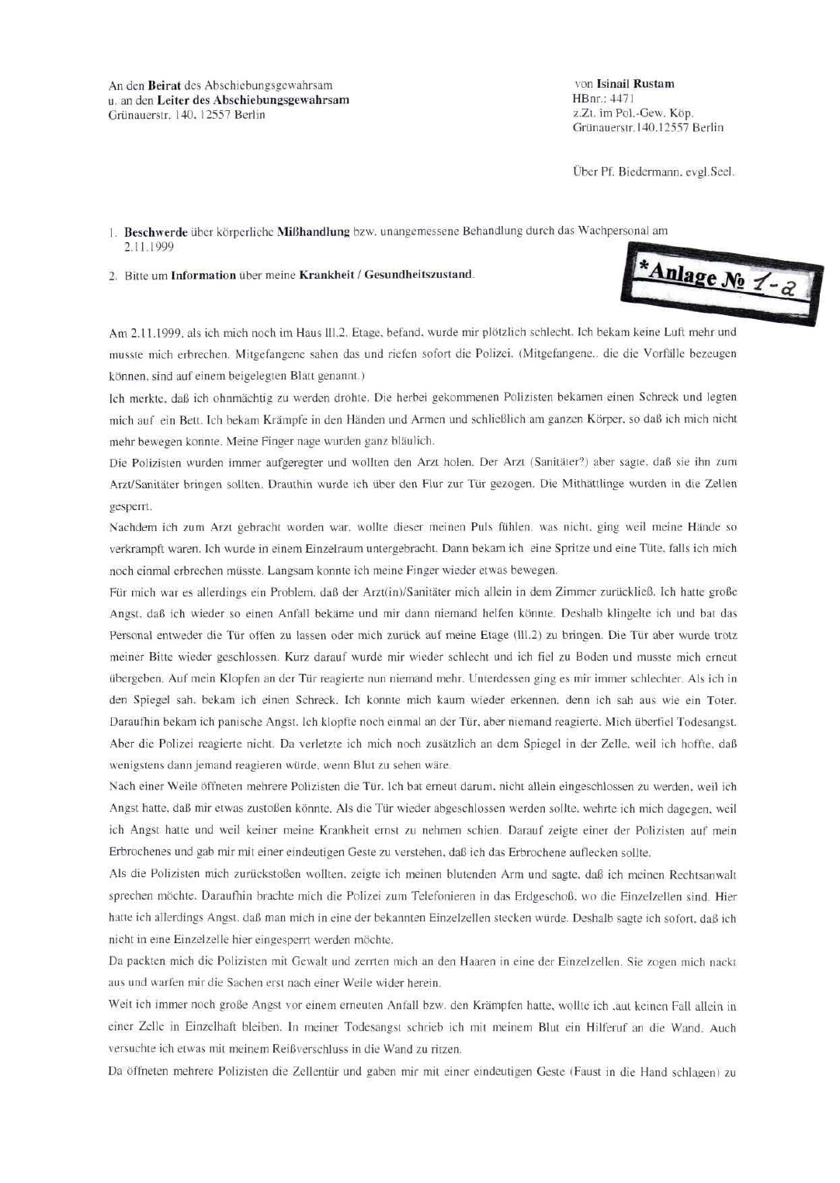

Figure B2 - OVG Berlin / AsylbLG proceedings, first page.
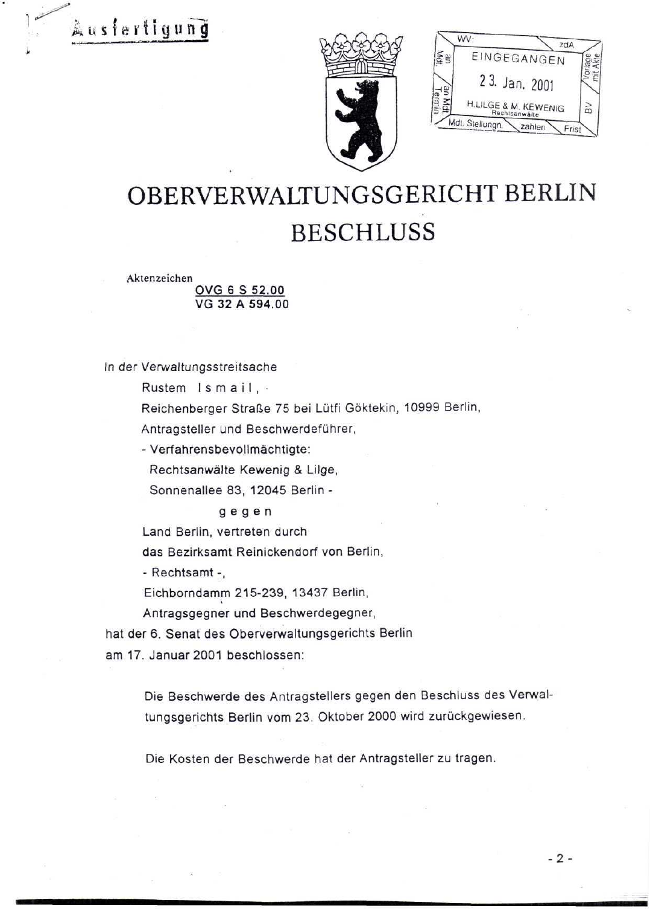

Figure B3 - Gesundheitsamt Mitte letter dated 29.11.2001.
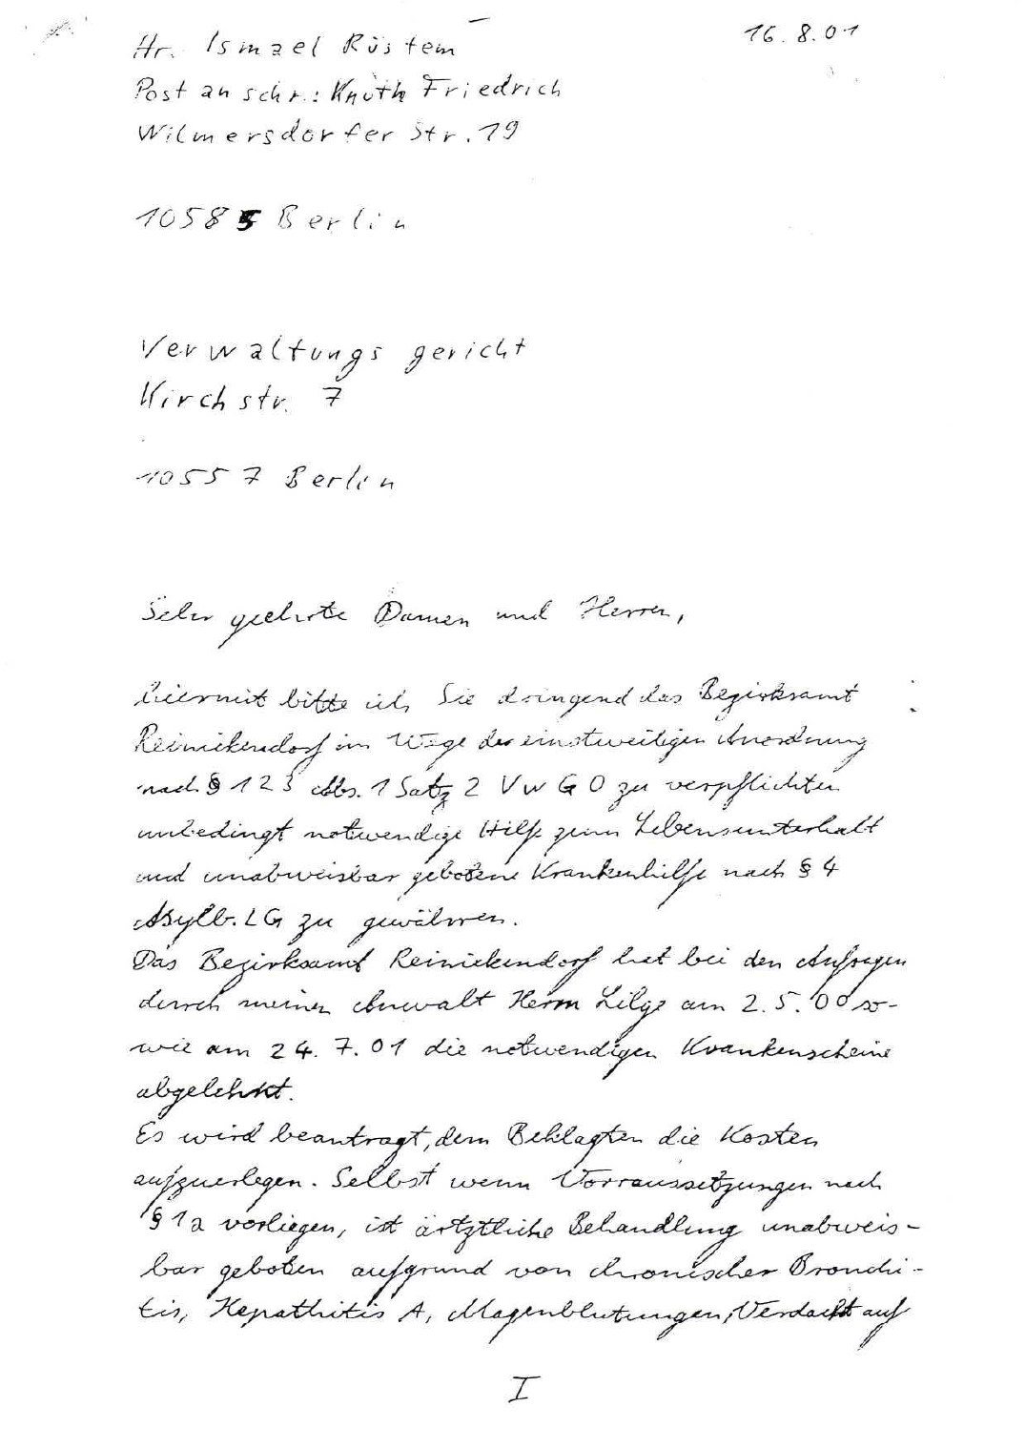

Figure B4 - Leonid Poljakov witness statement, first page.
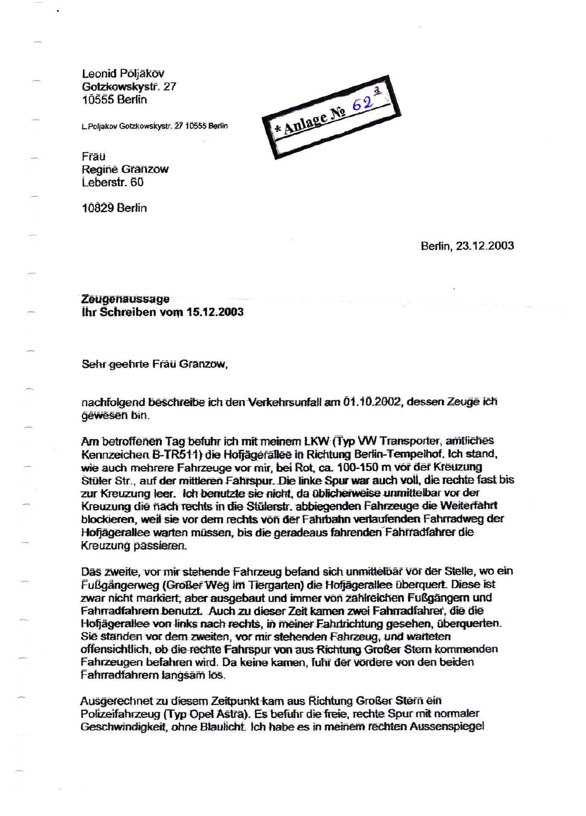

Figure B5 - Medical certificate dated 04.10.2002 following traffic accident.
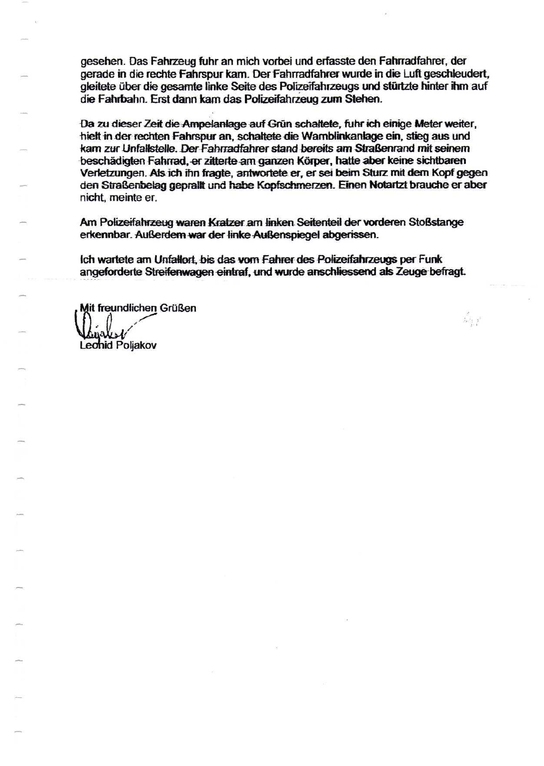

Figure B6 - ECHR complaint dated 18.10.2004, first page.
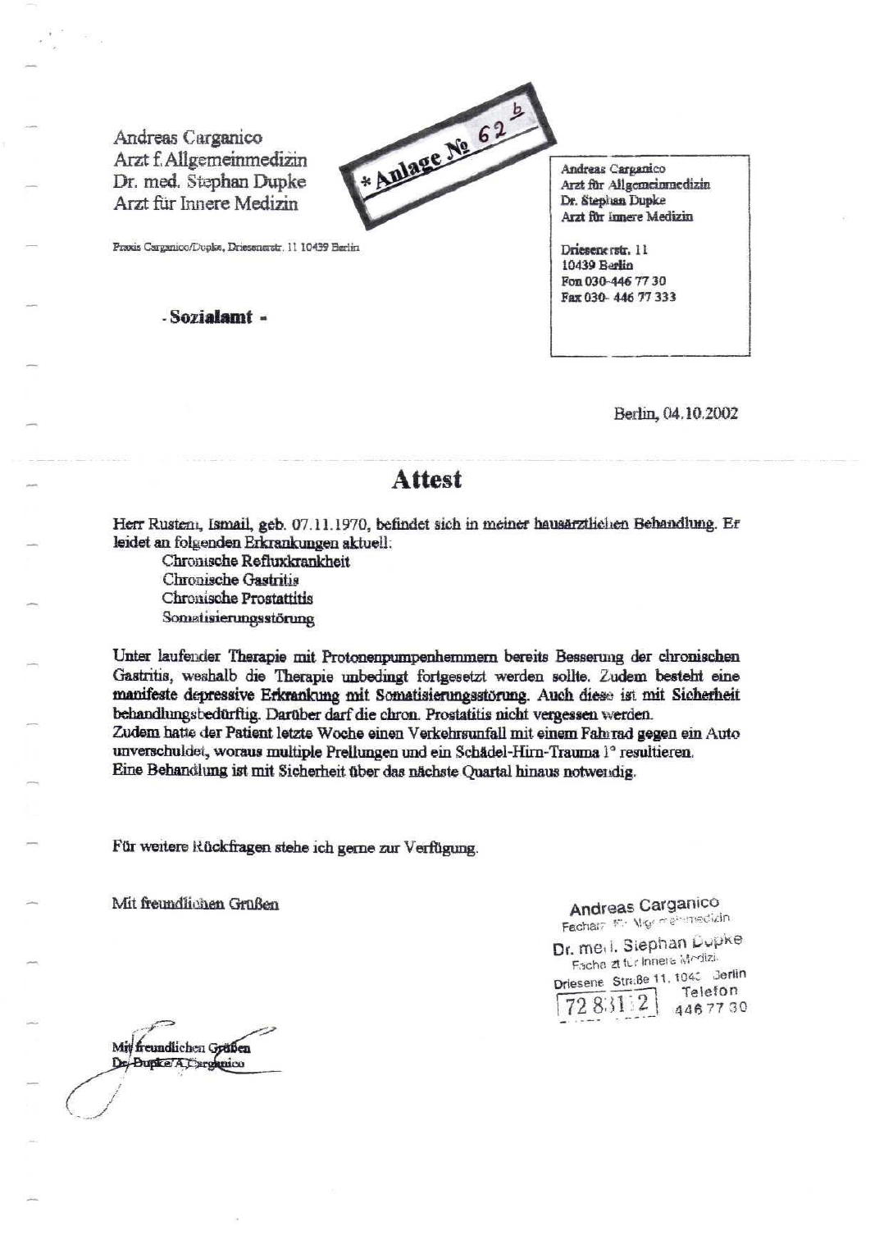

Figure B7 - Amtsgericht Tiergarten / 03.01.2005 materials page.
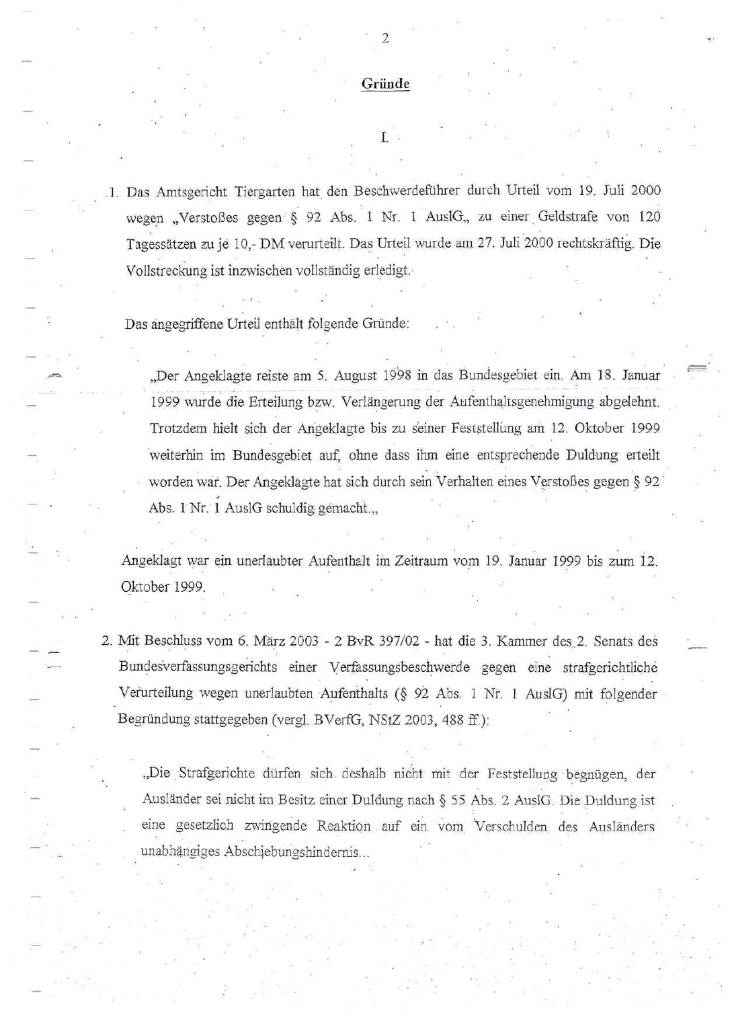

Figure B8 - RA Lilge fax dated 15.03.2006, first page.
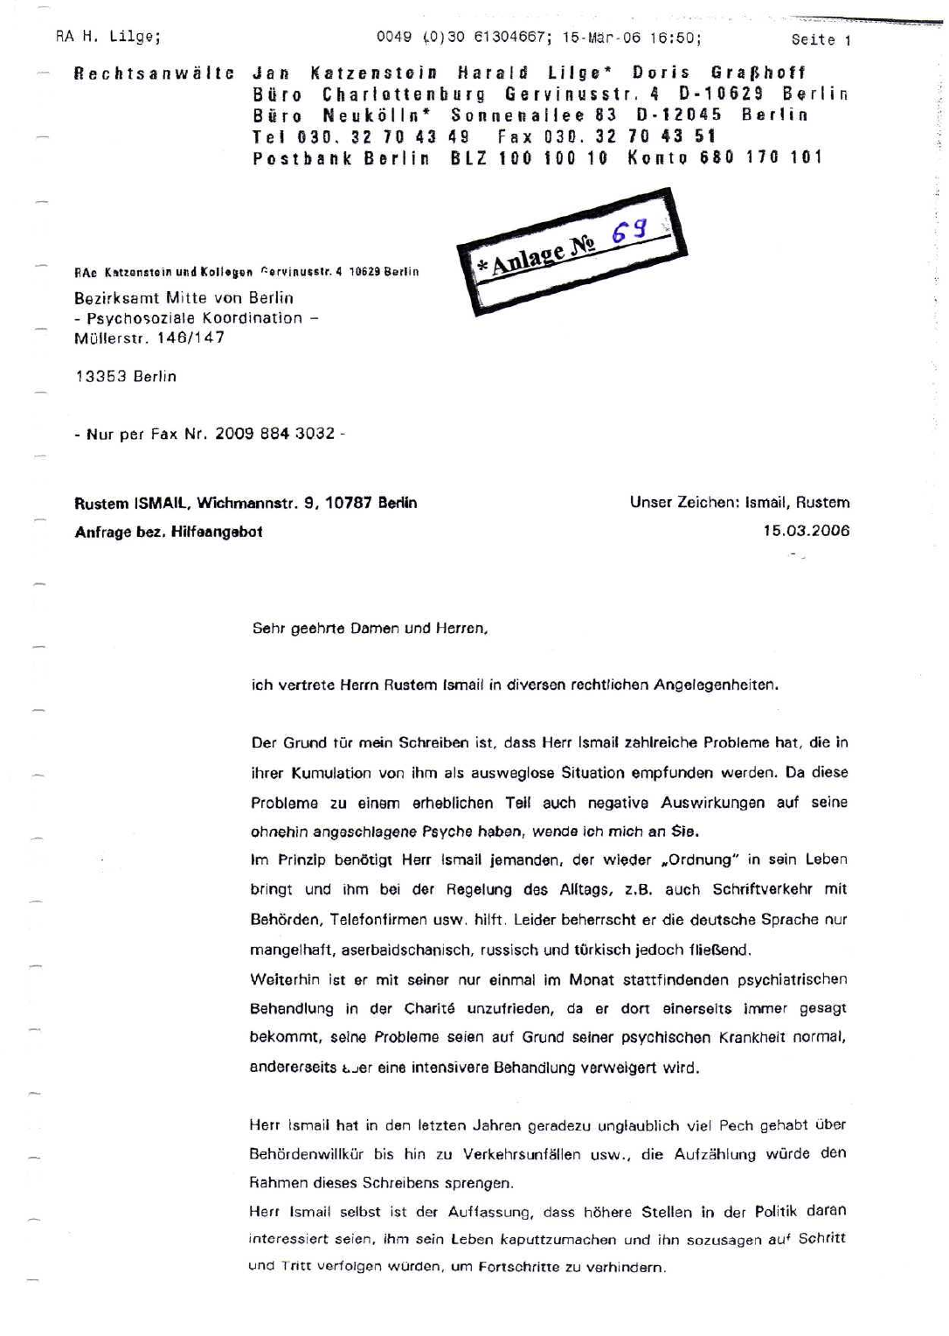

Expanded Edition Closing Statement
This expanded evidence edition supersedes the earlier narrower version of Report No. 006 where the earlier version did not include or did not fully integrate the primary documents and applicant clarification reviewed here. It is designed to be read together with Report No. 005. The next evidentiary step is not to reduce the matter to personal assertion, but to obtain the complete original files and compare each official decision with the medical, police, court and parliamentary materials that were available at the time.

